PROJECT REPORT

ON

**“****QR- based Advance Attendance System Using 2-Step Authentication”**

SUBMITTED IN PARTIAL FULFILMENT OF THE REQUIREMENT FOR THE DEGREE OF

**BACHELOR OF ENGINEERING**

In

**COMPUTER ENGINEERING**

By

**Harsh Ganesh Hiradeve Exam. No: B190434277**

**Ankit Bandu Kakade Exam. No: B190434297**

**Atharva Prakash Inkar Exam. No: B190434278**

**Aditya Rajendra Ekunkar Exam. No: B190434263**

Under the Guidance of

**Prof.V. K. Sambhar**



Submitted to

**DEPARTMENT OF COMPUTER ENGINEERING**

**STES’S SINHGAD ACADEMY OF ENGINEERING, PUNE-411048**

**2022-2023**



**CERTIFICATE**

This is to certify that the Project Report entitled

**QR- based Advance Attendance System Using 2-Step Authentication**

Submitted By

**Harsh Ganesh Hiradeve Exam. No: B190434277**

**Ankit Bandu Kakade Exam. No: B190434297**

**Atharva Prakash Inkar Exam. No: B190434278**

**Aditya Rajendra Ekunkar Exam. No: B190434263**

Is a bonafide work carried out by them under the supervision by **Prof. V. K. Sambhar** and it is approved for the partial fulfilment of the requirement of **Savitribai Phule Pune University** for the Project in the Final Year of Computer Engineering.

|  |  |  |
| --- | --- | --- |
| **Prof. V. K. Sambhar**  **Guide**  **Dept. of Computer Engg.** | **Prof. S.N.Shelke**  **H.O.D**  **Dept. of Computer Engg.** | **Dr. K. P. Patil**  **Principal**  **SAOE, Pune** |
|  |  |  |
| Place: Pune Date: / /2022 | **External Examiner** | **Prof. S.B.Ghawate Project Co-ordinator** |

**ACKNOWLEDGEMENT**

We would like to take this opportunity to thank all the people who were part of this seminar in numerous ways, people who gave un-ending support right from the initial stage.

In particular we wish to thank **Prof. V. K. Sambhar** as internal project guide who gave their co-operation timely and precious guidance without which this project would not have been a success. We thank them for reviewing the entire project with painstaking efforts and more of his, unbanning ability to spot the mistakes.

We would like to thank our **H.O.D Prof. S.N.Shelke** for his continuous encouragement, support and guidance at each and every stage of project.

And last but not the least we would like to thank all my friends who were Associated with me and helped me in preparing my project. The project named **“QR- based Advance Attendance System Using 2-Step Authentication”** would not been possible without the extensive support of people who were directly or indirectly involved in its successful execution.

**Project Group Members:**

**Harsh Ganesh Hiradeve Exam. No: B190434277**

**Ankit Bandu Kakade Exam. No: B190434297**

**Atharva Prakash Inkar Exam. No: B190434278**

**Aditya Rajendra Ekunkar Exam. No: B190434263**

**ABSTRACT**

Student participation in the classroom has a direct impact on their academic success in higher education institutions. The majority of student attendance registration is still done in the traditional manner, which is cumbersome and time- consuming, especially for courses with a significant number of students.The majority of institutions have historically handled attendance control by hand. The goal of this paper is to encourage the potential use of the Quick Response (QR) code as a future attendance management system, to track and record student attendance in lectures and exercises for all pertinent courses, in order to resolve the manual attendance issues. We proposed and implemented a smart attendance system to do this.

Keywords:- QR Code, attendance, system, professor, student.

**Table of Contents**

|  |  |  |  |  |  |  |  |
| --- | --- | --- | --- | --- | --- | --- | --- |
| **Sr.No.** | | | | **Title of Chapter** | | | **Page No.** |
|  | | | | Acknowledgment | | | iii |
|  | | | | Abstract | | | iv |
|  | | | | Table of Contents | | | v |
|  | | | | List of Tables | | | vii |
|  | | | | List of Figures | | | viii |
| **01** | | | | **Introduction** | | |  |
|  | 1.1 | | | Overview | | | 2 |
|  | 1.2 | | | Motivation | | | 3 |
|  | 1.3 | | | Problem Statement | | | 3 |
|  | 1.4 | | | Project Scope & Limitations | | | 3 |
| **02** | | | | Literature Review | | | 5 |
| **03** | | | | Software Requirements Specification | | | 8 |
|  | | 3.1 | | Assumptions and Dependencies | | | 9 |
|  | | 3.2 | | Functional Requirements | | | 9 |
|  | |  | | 3.2.1 | | System Feature 1(Functional Requirement) | 9 |
|  | |  | | 3.2.2 | | System Feature2 (Functional Requirement) | 9 |
|  | |  | |  | | …… |  |
|  | |  | |  | | …… |  |
|  | | 3.3 | | External Interface Requirements (If Any) | | |  |
|  | |  | | 3.3.1 | | User Interfaces |  |
|  | |  | | 3.3.2 | | Hardware Interfaces |  |
|  | |  | | 3.3.3 | | Software Interfaces |  |
|  | |  | | 3.3.4 | | Communication Interfaces |  |
|  | | 3.4 | | Nonfunctional Requirements | | |  |
|  | |  | | 3.4.1 | | Performance Requirements |  |
|  | |  | | 3.4.2 | | Safety Requirements |  |
|  | |  | | 3.4.3 | | Security Requirements |  |
|  | |  | | 3.4.4 | | Software Quality Attributes |  |
|  | | 3.5 | | System Requirements | | |  |
|  | |  | | 3.5.1 | | Database Requirements |  |
|  | |  | | 3.5.2 | | Software Requirements (Platform Choice) |  |
|  | |  | | 3.5.3 | | Hardware Requirements |  |
|  | | 3.6 | | Analysis Models: SDLC Model to be applied | | |  |
| **04** | | | | System Design | | |  |
|  | | 4.1 | | System Architecture | | |  |
|  | | 4.2 | | Mathematical Model | | |  |
|  | | 4.3 | | Data Flow Diagrams | | |  |
|  | | 4.4 | | Entity Relationship Diagrams | | |  |
|  | | 4.5 | | UML Diagrams | | |  |
| **05** | | | | Project Plan | | |  |
|  | | | 5.1 | Project Estimate | | |  |
|  | | |  | 5.1.1 | Reconciled Estimates | |  |
|  | | |  | 5.1.2 | Project Resources | |  |
|  | | | 5.2 | Risk Management | | |  |
|  | | |  | 5.2.1 | Risk Identification | |  |
|  | | |  | 5.2.2 | Risk Analysis | |  |
|  | | |  | 5.2.3 | Overview of Risk Mitigation, Monitoring, Management | |  |
|  | | | 5.3 | Project Schedule | | |  |
|  | | |  | 5.3.1 | Project Task Set | |  |
|  | | |  | 5.3.2 | Task Network | |  |
|  | | |  | 5.3.3 | Timeline Chart | |  |
|  | | | 5.4 | Team Organization | | |  |
|  | | |  | 5.4.1 | Team structure | |  |
|  | | |  | 5.4.2 | Management reporting and communication | |  |
| **06** | | | | Project Implementation | | |  |
|  | | | 6.1 | Overview of Project Modules | | |  |
|  | | | 6.2 | Tools and Technologies Used | | |  |
|  | | | 6.3 | Algorithm Details | | |  |
|  | | |  | 6.3.1 | Algorithm 1 | |  |
|  | | |  | 6.3.2 | Algorithm 2 | |  |
|  | | |  | 6.3.3 | … | |  |
| **07** | | | | Software Testing | | |  |
|  | | | 7.1 | Type of Testing | | |  |
|  | | | 7.2 | Test cases & Test Results | | |  |
| **08** | | | | Results | | |  |
|  | | | 8.1 | Outcomes | | |  |
|  | | | 8.2 | Screen Shots | | |  |
| **09** | | | | Conclusions | | |  |
|  | | 9.1 | | Conclusions | | |  |
|  | | 9.2 | | Future Work | | |  |
|  | | 9.3 | | Applications | | |  |
|  | | | | **Appendix A**:Problem statement feasibility assessment using, satisfiability analysis and NP Hard, NP-Complete or P type using modern algebra and relevant mathematical models.  **Appendix B**: Details of paper publication: name of the conference/journal, comments of reviewers, certificate, paper.  **Appendix C**: Plagiarism Report of project report. | | |  |
|  | | | | **References**  Thomas Noltey, Hans Hanssony, Lucia Lo Belloz,”Communication Buses for Automotive Applications” In *Proceedings of the* 3rd *Information Survivability Workshop (ISW-2007)*, Boston, Massachusetts, USA, October 2007. IEEE Computer Society. | | |  |

**List of Tables**

|  |  |  |
| --- | --- | --- |
| **S.no** | **Table name** | **Page no.** |
| 1 | System Implementation Plan | 19 |
| 2 | COCOMO model | 20 |
| 3 | Risk ID 1 | 22 |
| 4 | Risk ID 2 | 22 |

**List of Figures**

|  |  |  |
| --- | --- | --- |
| **S.no** | **Table name** | **Page no.** |
| 1 | System Architecture | 19 |
| 2 | Component diagram | 20 |
| 3 | Deployment Diagram | 22 |
| 4 | Welcome Page | 36 |
| 5 | Staff view | 36 |
| 6 | View Feedback | 37 |
| 7 | View student | 37 |
| 8 | Add previous project list | 38 |
| 9 | QR View | 38 |
| 10 | Admin Login Page | 39 |
| 11 | View Medical Certificate | 39 |
| 12 | Add notification | 40 |
| 13 | Add notes | 40 |
| 14 | View attendance | 41 |
| 15 | Staff login page | 41 |
| 16 | View Group details | 42 |
| 17 | Add Group Deatils | 42 |
| 18 | Student Feedback form | 43 |
| 19 | Download notes | 45 |
| 20 | Personal QR code | 46 |
| 21 | OTP | 47 |
| 22 | Student register page | 48 |

**Chapter 1**

**INTRODUCTION**

**1.1 Overview**

Nowadays, it’s crucial to complete tasks quickly, pick up new skills, and get better results as quickly and effectively as you can. Every sector needs management systems to enable them to have proper control and management in the development of learning or work, notably the educational process and the corporate world. We concluded that an online system to track student attendance is necessary for the university education process in particular after taking all these advantages and benefits into account. Regular attendance is among the most fundamental and crucial requirements in the educational system.

As a result, if the attendance requirement is not reached, the student may forfeit their ability to take an exam. Additionally, if students take more absences than permitted, they risk losing their ability to take the final exams. Given this, there is room for more calculation errors in the existing manual method. In order to address these problems, we suggested and created a superior web-based approach. Users of different computer systems, tablets, and mobile devices can utilise it with ease. The suggested approach offers data protection, allows for quick and easy access to attendance data for the entire class or specific students, and automatically generates reports for the professor. Using a special code for each professor and student known as a QR code, the internet-based attendance system’s goal is to computerise the conventional method of recording attendance and to give a simpler and more advanced approach to track institutions’ attendance today. Users (professors and students) are required to scan their individual QR code provided to them during or at the commencement of each lecture using QR reading devices within the classrooms at the start of each course to verify their attendance. The lecture and student attendance records as well as other essential information will be recorded in light of this. The approach will save a tonne of time while greatly enhancing student attendance in specific courses they must attend.

The goal of the smartphone-based attendance system is to modernise the out- dated method of keeping track of attendance in institutions by offering a simple, effective means to do so. Smartphones are currently the most popular device used in marketing and business. Additionally, there are several of them running Android OS.

**1.2 Motivation**

Most student attendance is still registered using the outdated method, which is difficult and time-consuming, especially for courses with a significant number of students.

**1.3 Problem Statement**

Attendance Management System is software developed for daily student attendance in colleges and institutes. It facialtes to access the attendance information of a particular student in a particular class. This system will also help in evaluating attendance eligibility criteria of a student. By just a click on the mouse the system will be able to produce the students attendance report thus reducing the need for manual labour which is prone to human errors and time consuming.

**1.4 Project Scope**

The system will generate unique QR codes for each individual.Users will be able to scan QR codes using their smartphones or dedicated scanning devices .It will record the attendance data, including date, time, and the individual's identification associated with the scanned QR code. The system will provide real-time updates to the administrator or relevant staff regarding attendance records. The system will generate reports and provide analytics to analyze attendance trends and patterns. The system will be compatible with existing systems, such as student management systems or employee databases, for seamless integration of attendance data.

**1.5 Limitations**

**Dependency on smartphones or devices:** QR-based attendance systems require participants to have smartphones or devices with QR code scanning capabilities. This can be a limitation if participants don't have access to smartphones or if the devices are not functioning properly.

**Internet connectivity:** QR codes often contain URLs that need to be accessed for attendance tracking. This requires a stable internet connection. In cases where the internet is unreliable or unavailable, the attendance system may not function properly.

**Limited scalability:** QR-based attendance systems may face challenges when handling a large number of participants simultaneously. Scanning QR codes individually for each participant can be time-consuming and may cause congestion in high-traffic areas.

**Chapter 2**

**LITERATURE REVIEW**

**2.1 Literature Survey**

Muhammad Ayat Hidayat, Holong, MarisiSimalango :- In this paper, We require a system for tracking student attendance that is effective at gathering information rapidly. By gathering data, analysing the system, designing the system, and putting it into practise, this student attendance system is accomplished. Android and PHP programming languages were used to construct this system. The goal of this project is to develop student-facing applications for attendance tracking and class notification systems based on IBEACON.

Dr.Nkolika O. Nwazor, Mumuni M. Olusolape:- This work uses the Centre for In- formation and Telecommunication Engineering at the University of Port Harcourt as a case study to design a cloud-based attendance management and information system. The implementation of a radio frequency identification tag reader and tag makes it possible to collect attendance data from both staff and students. A cloud-based information system application processed and stored the data received once it was processed from the tags’ data.

FawazAlassery:- In this study, we present a WSN-based time attendance system with sensor nodes embedded in sophisticated seats. We design a smart classroom that has five HX711 amplifiers and twenty 50 kg load sensors.

NandgopalDevnath, Nitin Pasi- This paper describes a created system that has been successfully constructed and tested. Analysis and export of the student’s attendance data will take place. Our daily lives depend greatly on the attendance tracking system. The most accurate code scanning technology available is the QR Code Based Smart Attendance System, which is a truly amazing advantage.

VasutanTunbunheng- In this paper, When collecting attendance, the DroidScript programme has to be connected to the internet because it uses Google’s speech recognition service for this study. In order to send data later when you connect to the internet, it may be better to register data when you’re not connected. This project could be expanded to include the collection of student grades for tests ad- ministered on paper. Another approach to expand this work is to have the students read their own codes and record their own noises to verify their identities.

Dongmei Feng, Peng Wang, Lei Zu:-This system satisfies the requirements of college professors and creates a fingerprint instrument, upper computer, and lower computer-based class attendance system. Once their fingerprints have been registered, students can carry out permanent fingerprint attendance.

Jaehoon (Paul) Jeong, Minho Kim, Yeonghyeon Lee, and Patrick Lingga:-This article suggests an Internet of Things-based Automatic Attendance System (called IAAS). Our objective is to offer a face recognition technology that is more depend- able and better for automatic attendance verification. To do this, a better system structure is built utilising appropriate face recognition technologies, and user face data is extracted using training data and the Haar-cascade method using training data.

Jack FebrianRusdi, Frans Richard Kodong-This system is based onface recognition for recording for recording education system for institutes, either as the primary system or as a support system for an already existing system.

**Chapter 3**

**Software Requirements and specifications**

**3.1 Assumptions and Dependencies**

* User must know English Language.
* The device has a 64-bit architecture.
* The User and the device on which the app is running must be indoors.
* A particular institution when required may approach our team and we can provide help for setting an indoor map. Hence, the must provide a blue print or plans of the building.

**3.2 Functional Requirements**

**3.2.1 System Feature 1(Functional Requirement).**

1. Student attendance system.
2. This is useful for colleges.

**3.3 External Interface Requirements**

**3.3.1 User Interfaces**

Home page

Registration and Login Page QR Code Page

Result Page

**3.3.2 Hardware Interfaces**

The entire software requires a completely equipped computer system including monitor, keyboard, and other input output devices.

**3.3.3 Software Interfaces**

The system can use Microsoft as the operating system platform. System also makes use of certain GUI tools. To run this application we need python and above as windows platform and Apache tomcat as server. To store data we need MySQL database.

**3.3.4 Communication Interfaces**

Communication using servers.

**3.4 Non-Functional Requirements**

**3.4.1 Performance Requirements**

The performance of the system lies in the way it is handled. Every user must be given proper guidance regarding how to use the system. The other factor which affects the performance is the absence of any of the suggested requirements.

**3.4.2 Safety Requirements**

To ensure the safety of the system, perform regular monitoring of the system so as to trace the proper working of the system. An authenticated user is only able to access system.

**3.4.3 Security Requirements**

Any unauthorized user should be prevented from accessing the system. Password authentication can be introduced.

**3.4.4 Software Quality Attributes**

**Accuracy: -**

The level of accuracy in the proposed system will be higher. All operation would be done correctly and it ensures that whatever information is coming from the center is accurate. Result is organic results.

**Reliability: -**

The reliability of the proposed system will be high due to the above stated reasons. The reason for the increased reliability of the system is that now there would be proper storage of information and Recommending location model.

**3.5 System Requirements**

**3.5.1 Database Requirements**

* MySQL Database

**3.5.2 Software Requirements(Platform Choice)**

• Operating System - Windows

• Application Server - Apache Tomcat

• Front End - HTML, JDK 1.7, JSP

• Language - Java.

• Database - My SQL 5.0

• IDE - Eclipse

**3.5.3 Hardware Requirements**

• Processor - I3/I5

• Speed - 3.1 GHz

• RAM - 2GB(min)

• Hard Disk - 20 GB

• Key Board - Standard Windows Keyboard

• Mouse - Two or Three Button Mouse

• Monitor - SVGA

**3.6 Analysis Models: SDLC Model to be applied**

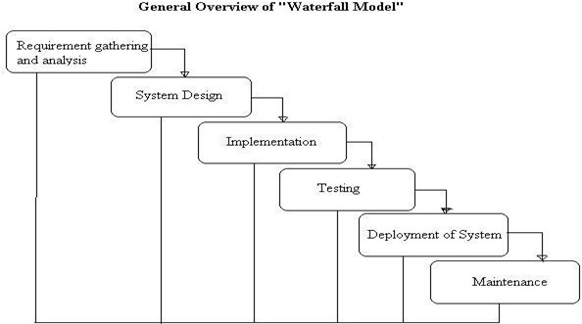

The Waterfall Model is sequential design process, often used in Software development processes, where progress is seen as flowing steadily download through the phase of conception, Initiation, Analysis, Design, Construction, Testing, Production/Implementation and Maintenance. This Model is also called as the classic Life cycle model as it suggests a systematic sequential approach to software developments. This one of the oldest model followed in software engineering. The process begins with the communication phase where the customer specifies the requirements and then progress through other phases like planning, modeling, construction and deployment of the software.

There are 5 Phase of water fall model:

The Waterfall Model is sequential design process, often used in Software development processes, where progress is seen as flowing steadily download through the phase of conception, Initiation, Analysis, Design, Construction, Testing, Production/Implementation and Maintenance. This Model is also called as the classic Life cycle model as it suggests a systematic sequential approach to software developments. This one of the oldest model followed in software engineering. The process begins with the communication phase where the customer specifies the requirements and then progress through other phases like planning, modeling, construction and deployment of the software.

There are 5 Phase of water fall model:

**1.COMMUNICATION**

In communication phase the major task performed is requirement gathering which helps in finding out exact need of customer. Once all the needs of the customer are gathered the next step is planning.

**2.PLANNING**

In planning major activities like planning for schedule, keeping tracks on the pro- cesses and the estimation related to the project are done. Planning is even used to find the types of risks involved throughout the projects. Planning describes how technical tasks are going to take place and what resources are needed and how to use them.

**3.MODELING**

This is one the important phases as the architecture of the system is designed in this phase. Analysis is carried out and depending on the analysis a software model is designed. Different models for developing software are created depending on the requirements gathered in the first phase and the planning done in the second phase.

**4.CONSTRUCTION**

The actual coding of the software is done in this phase. This coding is done on the basis of the model designed in the modeling phase. So in this phase software is actually developed and tested.

**5.DEPLOYMENT**

In this last phase the product is actually rolled out or delivered installed at cus- tomer’s end and support is given if required. A feedback is taken from the customer to ensure the quality of the product. From the last two decades Waterfall model has come under lot of criticism due to its efficiency issues. So let’s discuss the advantages and disadvantages of waterfall model.

**Chapter 4**

**SYSTEM DESIGN**

**4.1 System Architecture**

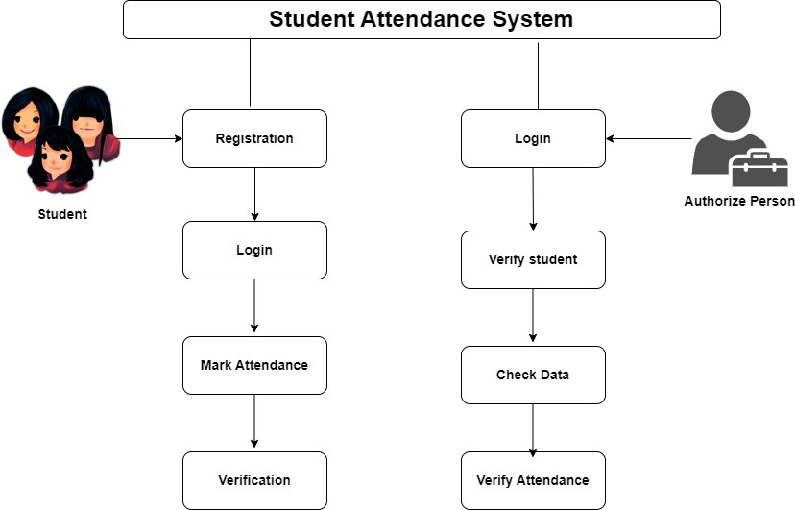

Fig. 4.1: System Architecture

**4.2 Data Flow Diagrams:**

**4.2.1 Level 0 data flow diagram**

1. The DFD is also called as bubble chart. It is a simple graphical formalism that can be used to represent a system in terms of input data to the system, various processing carried out on this data, and the output data is generated by this system.

2. The data flow diagram (DFD) is one of the most important modeling tools. It is used to model the system components. These components are the system process, the data used by the process, an external entity that interacts with the system and the information ows in the system.

3. level 0 DFD which shows how the information moves through the system and how it is modified by a series of transformations. It is a graphical technique that depicts information ow and the transformations that are applied as data moves from input to output.

**4.3 UML Diagrams**

**4.3.1 Component Diagram**

A Component Diagram displays the structural relationship of components of a software system. These are mostly used when working with complex systems that have many components. Components communicate with each other using inter- faces. The interfaces are linked using connectors.

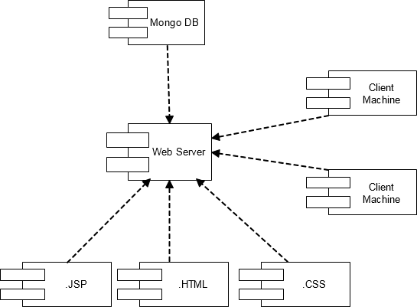

Fig. 4.2: Component Diagram

**4.3.2 Deployment Diagram**

Deployment diagrams are used to visualize the topology of the physical components of a system where the software components are deployed. So deployment diagrams are used to describe the static deployment view of a system. Deployment diagrams consist of nodes and their relationships.

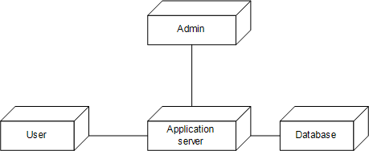

Fig. 4.3: Deployment Diagram

**CHAPTER 5**

**PROJECT PLAN**

**5.1 Implementation plan**

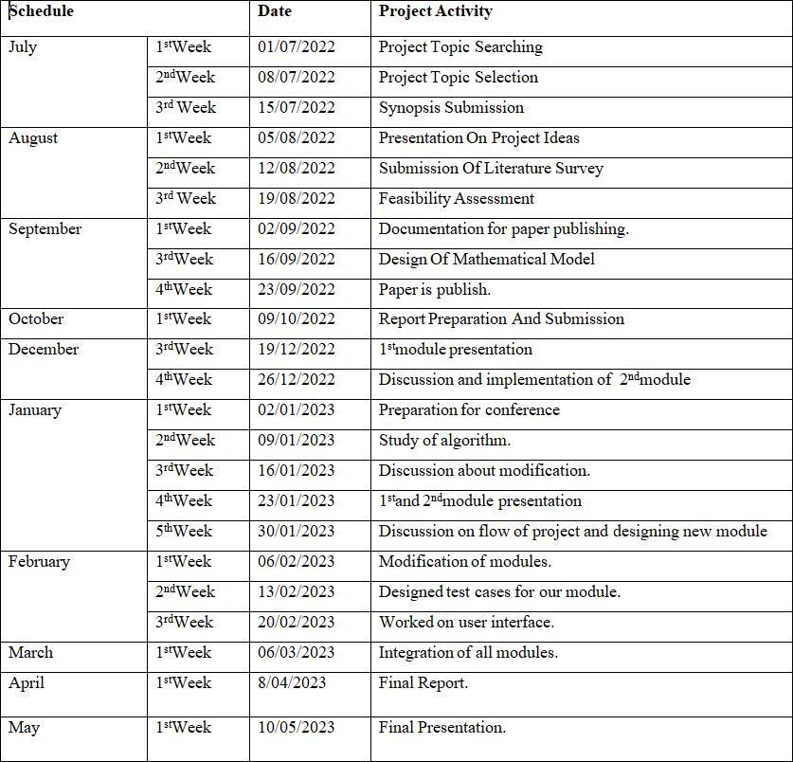

|  |  |  |
| --- | --- | --- |
| **Sr. no** | **Modules** | **KLOC (**Thousands (Kilo) of Lines of Code**)** |
| 1 | Graphical User Interface | 1.80 |
| 2 | User Authentication Code | 0.80 |
| 3 | Device Drivers | 3 0.60 |
| 4 | Interfacing Code (Java Applets , Swing and Algorithms) | 4 0.70 |

**5.1.2 COCOMO Model**

Cocomo (Constructive Cost Model) is a regression model based on LOC, i.e number of Lines of Code. It is a procedural cost estimate model for software projects and often used as a process of reliably predicting the various parameters associated with making a project such as size, effort, cost, time and quality.

The key parameters which define the quality of any software products, which are also an outcome of the Cocomo are primarily Effort Schedule:

Effort:Amountof labor that will be required to complete a task. It is measured in person-months units.

Schedule: Simply means the amount of time required for the completion of the job, which is, of course, proportional to the effort put. It is measured in the units of time such as weeks, months.

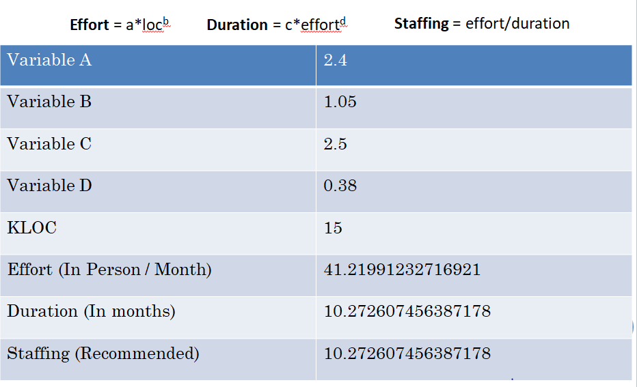

Table 3.2: COCOMO Model

**5.2 Risk Identification**

The step in measuring level of risk is to determine the adverse impact resulting from a successful threat exercise of vulnerability. The adverse impact of a security event can be described in terms of loss or degradation of any, or combination of any, of the following three security goals: integrity, availability, and confidentiality that can be describes qualitative categories as high, medium, low.

**5.2.1 Risk Analysis**

Risk identification and analysis is important to priorities the implementation (extent and time frame) of governance and controls, as well as to establish scope for reviewing or auditing database environments. Based on the identification and analysis of risks, controls should be designed and implemented to ensure that necessary actions are taken to address risks and to achieve business and IT objectives.

**5.2.3 Overview of Risk Mitigation, Monitoring, Management**

The identification of Risk is central to the success and failure of the project, hence we have made a concentrated effort to minimize and even eliminate. Certain risk related. Software risk could be classified into categories. Internal and External risk, those risk which arise from the risk factor within the organization can be defined internal risk and the risk coming from outside is called external risk. Internal risk avoidance can be done by clear picturing the process, product risk. Following are the details for each risk:

|  |  |
| --- | --- |
| Risk ID | 1 |
|  |  |
| Risk Description | System failure |
|  |  |
| Category | Requirements |
|  |  |
| Source | This was identified during early development and testing |
|  |  |
| Probability | Low |
|  |  |
| Impact | High |
|  |  |
| Response | Accept |
|  |  |
| Strategy | Better Internet connection will solve this |
|  |  |
| Risk Status | Occurred |
|  |  |
|  |  |
| Risk ID | 2 |
|  |  |
| Risk Description | Connection failure |
|  |  |
| Category | Requirements |
|  |  |
| Source | This was identified during early development and testing |
|  |  |
| Probability | Low |
|  |  |
| Impact | High |
|  |  |
| Response | Mitigate |
|  |  |
| Strategy | Proper authentication will resolve this issue. |
|  |  |

**CHAPTER 6**

**Project Implementation**

**6.1 Overview of Project Modules**

* **User**
* User first register account in application.
* After activate account, user should login.
* After login user can scan QR code and mark attendance.

**6.2 Tools and Technologies Used**

**Hardware Requirements:**

Processor - Intel i3 core

Speed - 1.1 GHz

RAM - 256 MB (min)

Hard Disk - 20 GB

Key Board - Standard Windows Keyboard

Mouse - Two or Three Button Mouse\

**Software Requirements:**

Operating System : Windows 7

Coding language : JAVA (JDK 7.0)

Database : MySQL 5.0

IDE : Eclipse Luna

**CHAPTER 7**

**SOFTWARE TESTING**

**System Testing**

For system testing we test to perform validations and verifications on users every input and then processed such as user personal details, uploaded image format, uploaded image type and more.

After performing the integration testing, the next step is output testing of the proposed system.

No system could be useful if it does not produce the required output in a specified format. The outputs generated are displayed by the user.

**Project aspect:**

The entire project was tested and found successful.

**7.4 Test Plan**

Test Plan Identifier: cost-sensitive

It is use to identify test plan uniquely.

**1. Purpose of the Test Plan Document**

The main purpose of this document is to fit a particular projects needs. It documents and tracks the necessary information required to effectively define the approach to be used in the testing of the projects product. The Test Plan document is created during thePlanning Phase of the project. Its intended audience is the project manager, project team,and testing team.

**2. Objective of Test Panning**

To find as many defects as possible and get them fix.

**3. Items to be tested OR not to be tested**

Describe the items/features/functions to betested that are within the scope of this testplan. Include a description of how they will be tested, when, by whom, and to whatquality standards. Also include a description of those items agreed not to be tested.

**4. Items to be tested**

Overall functionality of the application

User Interface of the application.

**5. Test Approach**

Describe the overall testing approach to be used to test the projects product. Provide anoutline of any planned tests. There are many approaches like:Black Box Testing White Box Testing

Here we used Black Box Testing approach. In Black Box Testing we just give input to the system and check its output without checking how system processes it.

**6. Test Pass OR Test Fail Criteria**

When actual and expected results are same then test will be passed. When actual andexpected results are different then test will be failed.

**7. Test Entry OR Exit Criteria**

Describe the entry and exit criteria used to start testing and determine when to stop testing.

Entry criteria: As soon as we have requirement we can start testing.

Exit criteria: When bug rate fall below certain level we can stop testing.

**8. Test Suspension OR Resumption Criteria**

Describe the suspension criteria that may be used to suspend all or portions of testing.

Also describe the resumption criteria that may be used to resume testing.

Suspension criteria: If there is large change in application like change in requirementswe can suspend work for some time.

Resumption criteria: After resolving the respective problem we can resume work. Item

Testing Type

It describes which testing types we are going to follow in our testing lifecycle. Here weare using:

**UI Testing**

**Integration Testing**

**9. Test Cases**

Test cases are built around specifications and requirements, i.e., what the application issupposed to do. Test cases are generally derived from external descriptions of the software,including specifications, requirements and design parameters. Although the testsused are primarily functional in nature, non-functional tests may also be used. The testdesigner selects both valid and invalid inputs and determines the correct output withoutany knowledge of the test object’s internal structure. Test Design Techniques

Typical black-box test design techniques include:

* Decision table testing
* All-pairs testing
* State transition Analysis
* Equivalence partitioning
* Boundary value analysis
* Causeeffect graph
* Error guessing

**Advantages**

* Efficient when used on large systems.
* Since the tester and developer are independent of each other, testing is balanced and unprejudiced.
* Tester can be non-technical.
* There is no need for the tester to have detailed functional knowledge of system.
* Tests will be done from an end user’s point of view, because the end user should accept the system. (This testing technique is sometimes also called Acceptance testing.)
* Testing helps to identify vagueness and contradictions in functional specifications.
* Test cases can be designed as soon as the functional specifications are complete.

**Disadvantages**

* Test cases are challenging to design without having clear functional specifications.
* It is difficult to identify tricky inputs if the test cases are not developed based on specifications.
* It is difficult to identify all possible inputs in limited testing time. As a result, writing test cases may be slow and difficult.
* There are chances of having unidentified paths during the testing process.
* There is a high probability of repeating tests already performed by the programmer.

**Test case For Registration and Login Page:**

.

Total no of test Cases:-04

Total no of test Cases Passed:-04

Total no of test Cases failed:-00

Total no of test Cases executed:-04

Total no of test Cases pending:-00

|  |  |  |  |  |  |
| --- | --- | --- | --- | --- | --- |
| **Test Case ID** | **Test Case Procedure** | **Input**  **Data** | **Expected**  **Output** | **Actual Output** | **Test**  **Status** |
| POI -LO-01 | Checking the functionality of Login Button | 1.Enter valid User name  2 .Enter valid Password  3. Click on Login Button | Login page should be displayed | Login page displayed | Pass |
| POI -LO-02 | Checking the functionality of Login Button | 1.Enter valid User name  2 .Enter Invalid Password  2. Click on Login Button | Login page should not be displayed | Login page not displayed | Pass |
| POI -LO-03 | Checking the functionality of Login Button | 1.Enter Invalid User name  2 .Enter valid Password  2. Click on Login Button | Login page should not be displayed | Login page not displayed | Pass |
| POI -LO-04 | Checking the functionality of Login Button | 1.Enter Invalid User name  2 .Enter Invalid Password  2. Click on Login Button | Login page should not be displayed | Login page not displayed | Pass |

**Module Name: Register.**

Total no of test Cases:-05

Total no of test Cases Passed:-05

Total no of test Cases failed:-00

Total no of test Cases executed:-05

Total no of test Cases pending:-00

|  |  |  |  |  |  |
| --- | --- | --- | --- | --- | --- |
| **Test Case ID** | **Test Case Procedure** | **Input**  **Data** | **Expected**  **Output** | **Actual Output** | **Test**  **Status** |
| POI -LO-01 | Checking the functionality of Register Button | 1.Enter User name  2 .Enter valid email address  3. Enter valid mobile No.  4. Enter valid password i.e. in specific format.  5.Click on Register Button | Register page should be displayed | After Registration, Login page displayed | Pass |
| POI -LO-02 | Checking the functionality of Register Button | 1.Enter User name  2 .Enter invalid email address  3. Enter valid mobile No.  4. Enter valid password i.e. in specific format.  5.Click on Register Button | Registration Fail. | Registration Fail. | Pass |
| POI -LO-03 | Checking the functionality of Register Button | 1.Enter User name  2 .Enter valid email address  3. Enter invalid mobile No.  4. Enter valid password i.e. in specific format.  5.Click on Register Button | Registration Fail. | Registration Fail. | Pass |
| POI -LO-04 | Checking the functionality of Register Button | 1.Enter User name  2 .Enter valid email address  3. Enter valid mobile No.  4. Enter invalid password i.e. not in specific format.  5.Click on Register Button | Registration Fail. | Registration Fail. | Pass |
| POI -LO-05 | Checking the functionality of Register Button | 1.Enter User name  2 .Enter invalid email address  3. Enter invalid mobile No.  4. Enter invalid password i.e. not in specific format.  5.Click on Register Button | Registration Fail. | Registration Fail. | Pass |

**Test Cases for Documents Upload:**

Total no of test Cases:-02

Total no of test Cases Passed:-02

Total no of test Cases failed:-00

Total no of test Cases executed:-02

Total no of test Cases pending:-00

|  |  |  |  |  |  |
| --- | --- | --- | --- | --- | --- |
| **Test Case ID** | **Test Case Procedure** | **Input**  **Data** | **Expected**  **Output** | **Actual Output** | **Test**  **Status** |
| POI -LO-01 | Checking the functionality of browse Button | 1. Upload valid image  2. Click on Upload Button | Uploaded image should be displayed | Uploaded image displayed | Pass |
| POI -LO-02 | Checking the functionality of browse Button | 1. Upload invalid image  2. Click on Upload Button | Uploaded image should not be displayed | Uploaded image not displayed | Pass |

**CHAPTER 8**

**RESULTS**

**8.1 Screen Shots**

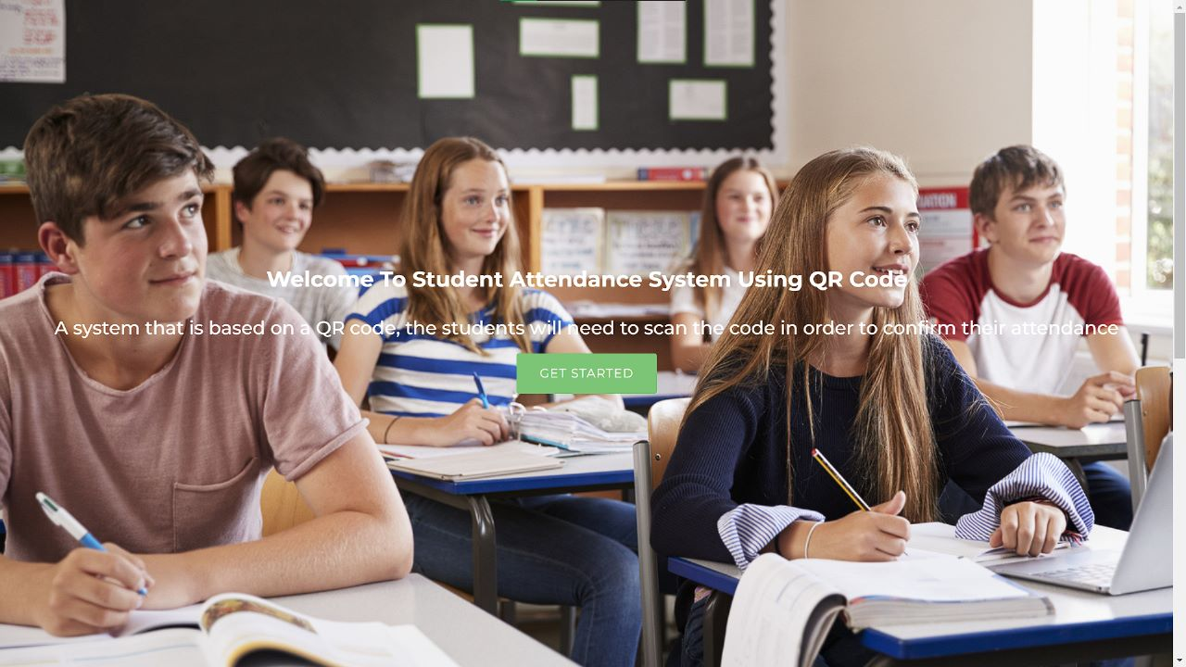

**Fig 1:-Home page**

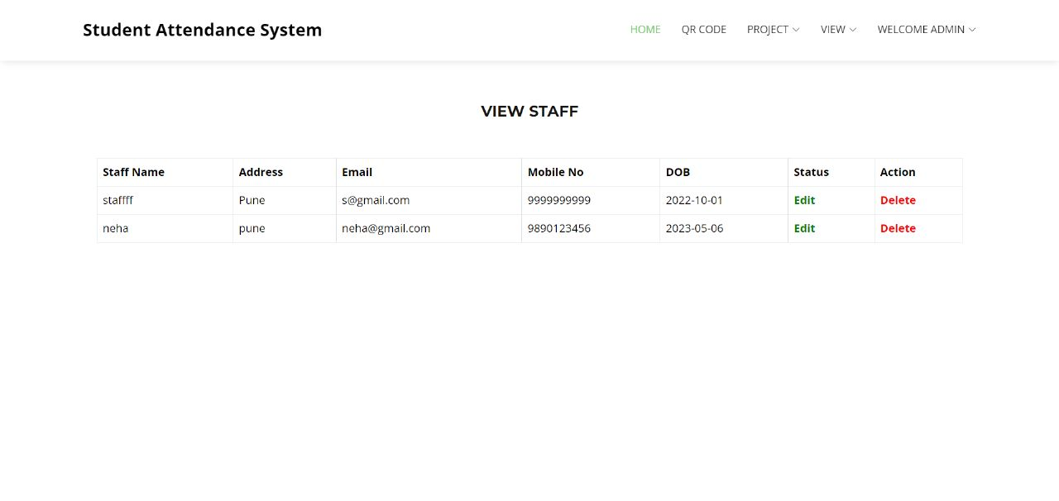

**Fig 2:- Staff View**

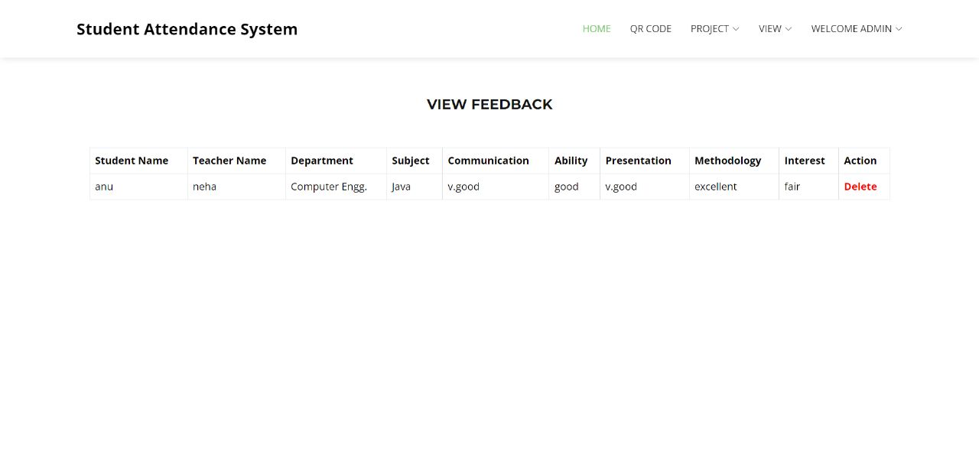

**Fig 3:- View Feedback**

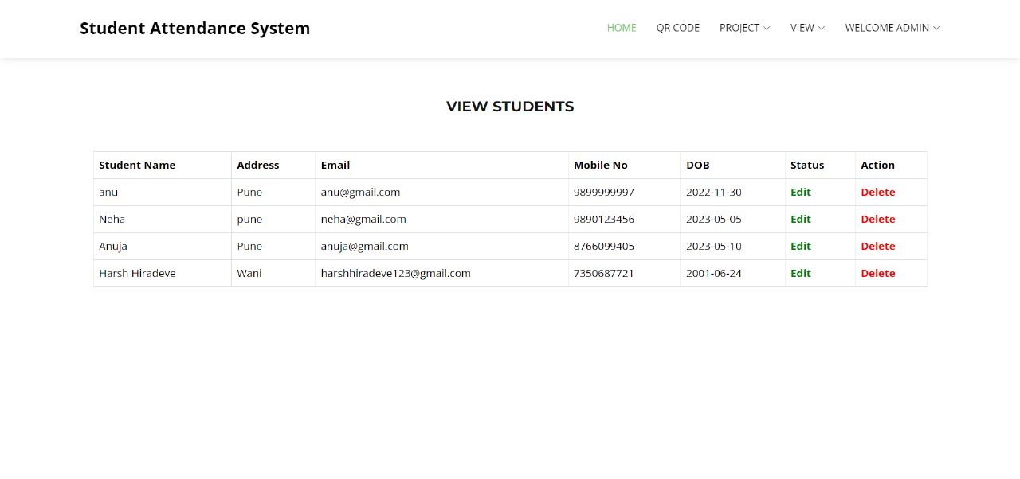

**Fig 4:- View Student**

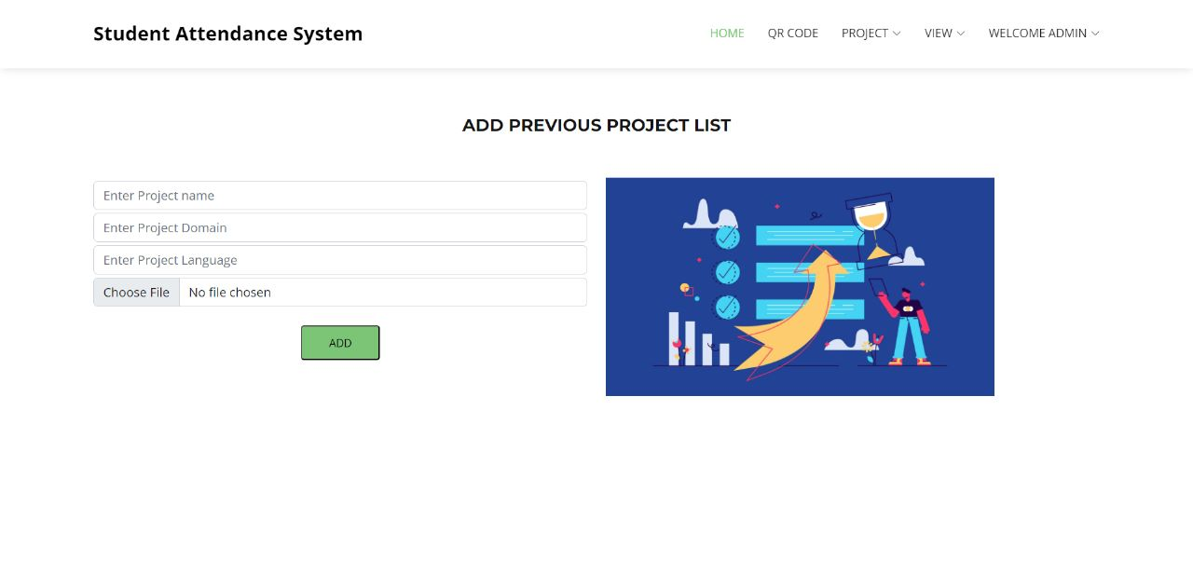

**Fig 5:- Add Previous Project List**

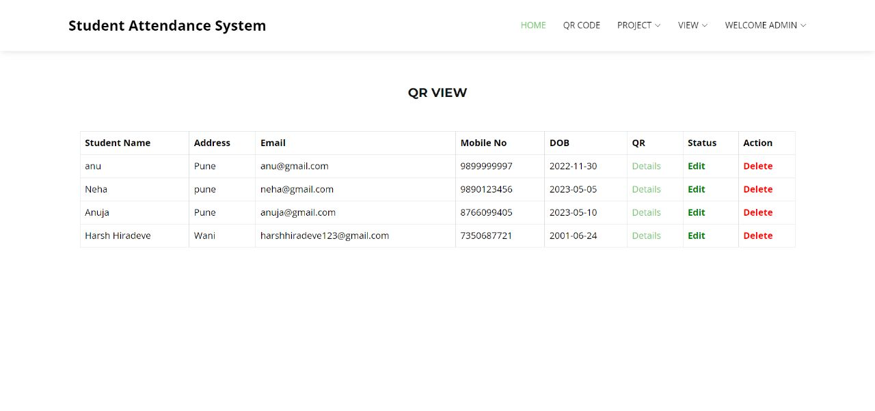

**Fig 6:- QR View**

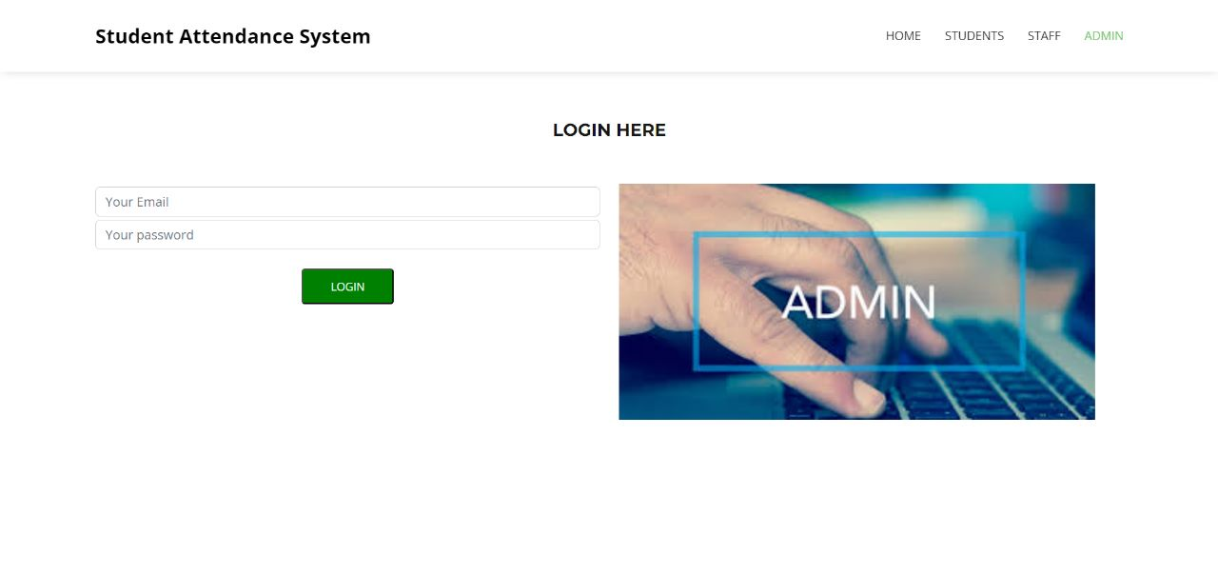

**Fig 7:- Admin Login Page**

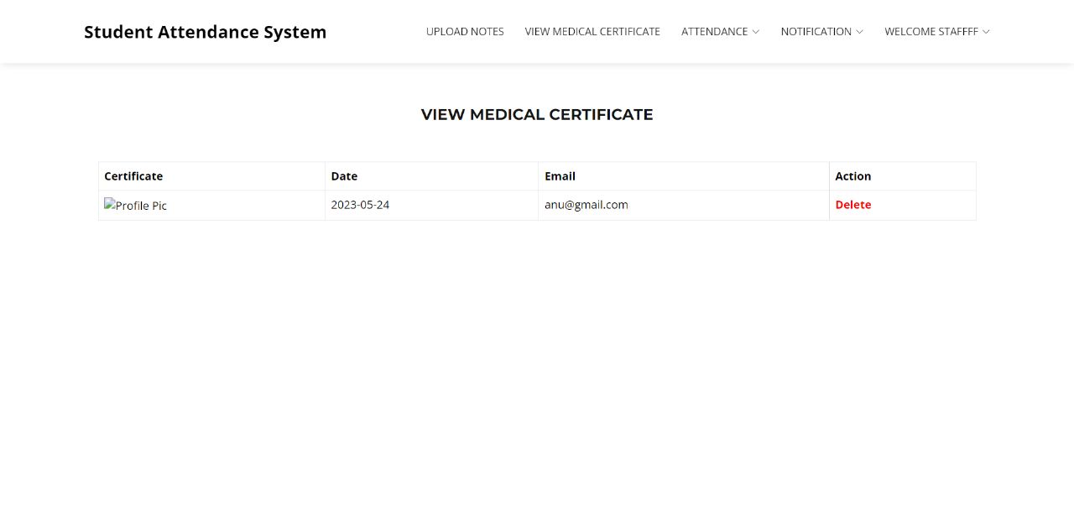

**Fig 8:- View Medical Certificate**

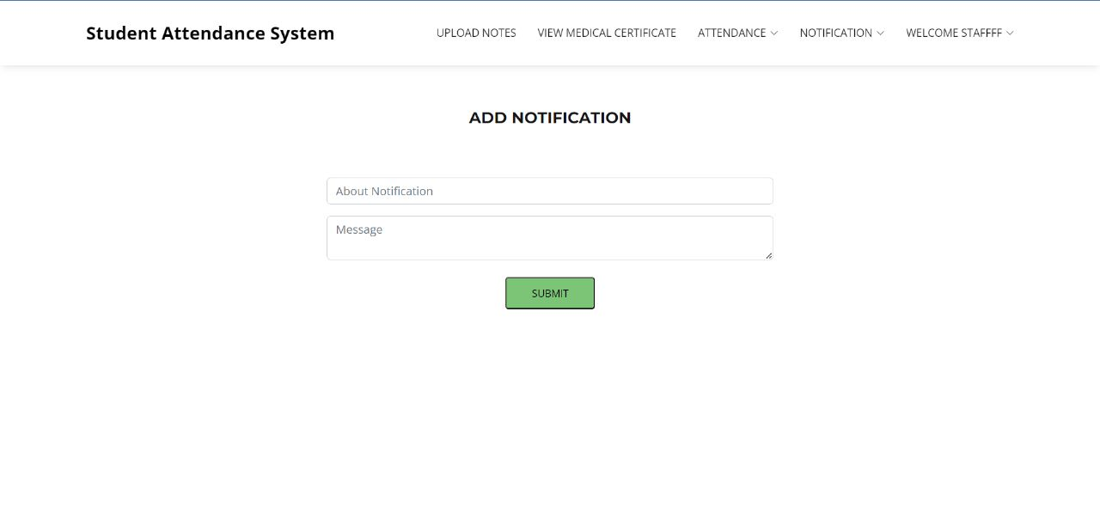

**Fig 9:- Add Notification**

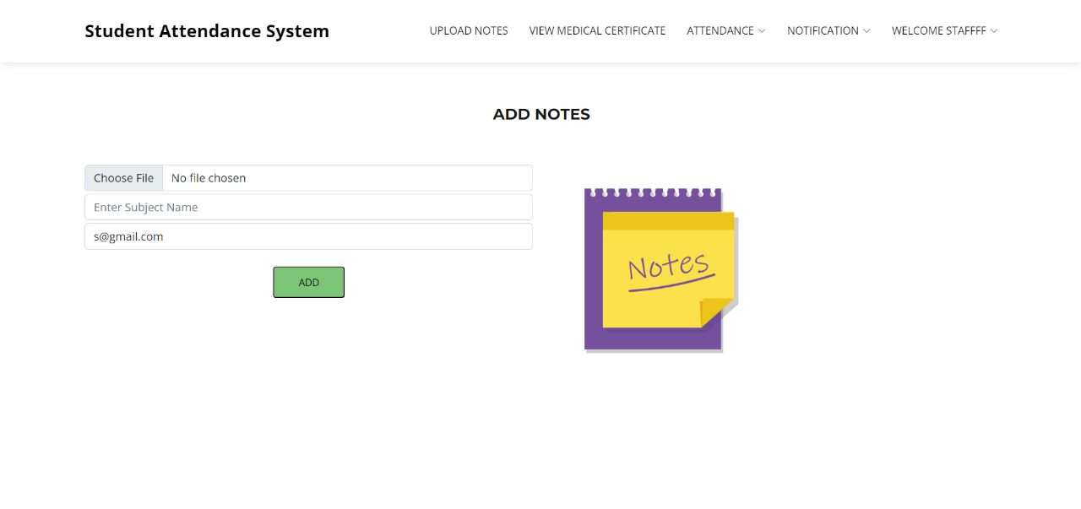

**Fig 10:- Add Notes**

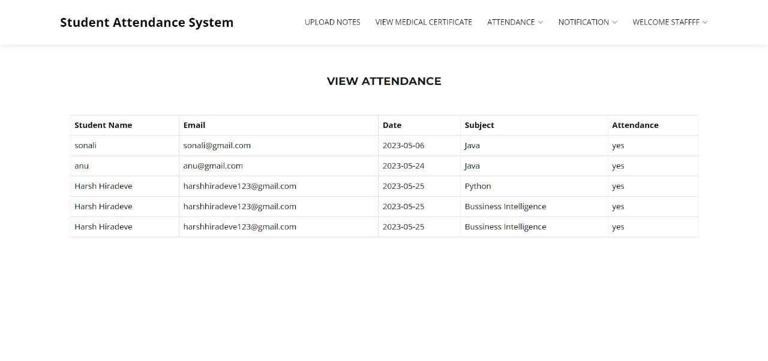

**Fig 11:- View Attendance**

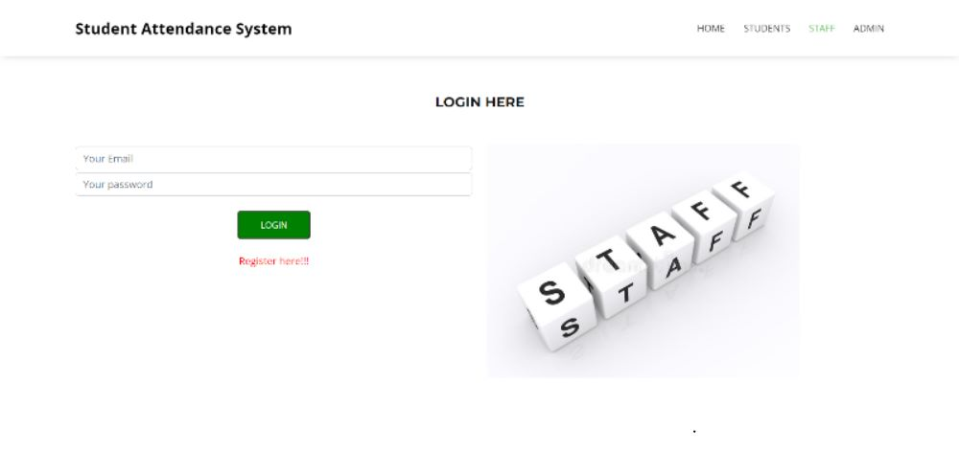

**Fig 12:- Staff Login Page**

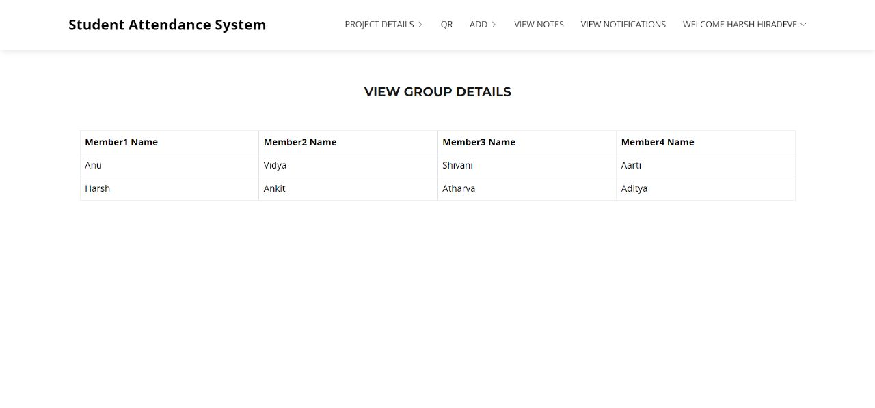

**Fig 13:- View Group Details**

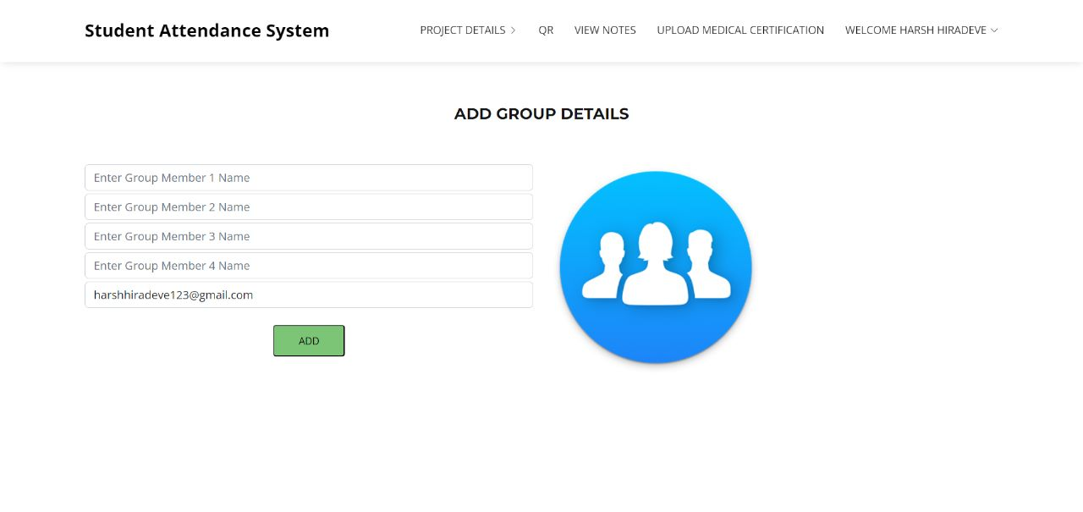

**Fig 14:- Add Group Details**

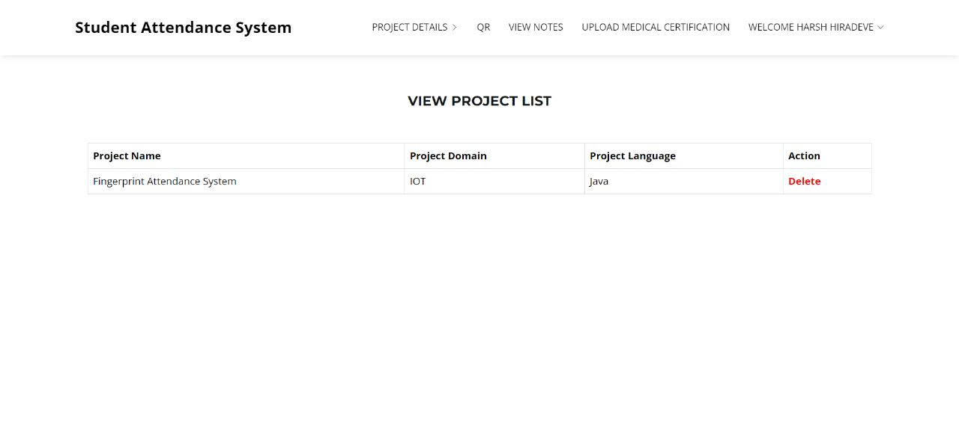

**Fig 15:- View Project List**

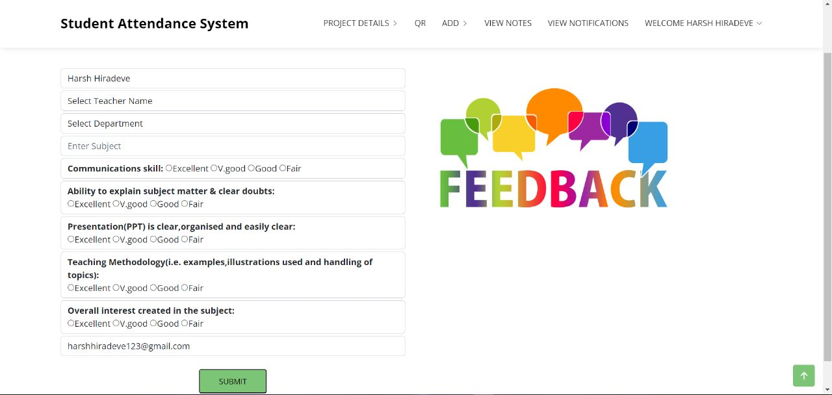

**Fig 16:- Student Feedback Form**

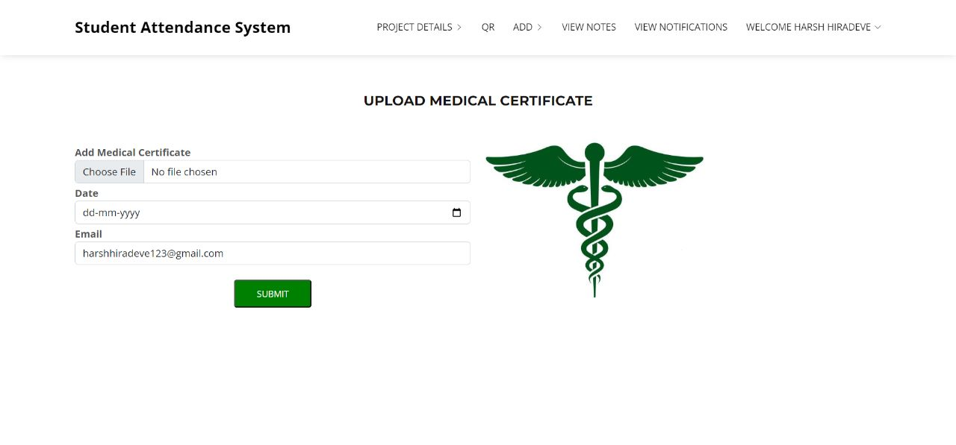

**Fig 17:- Upload Medical Certificate**

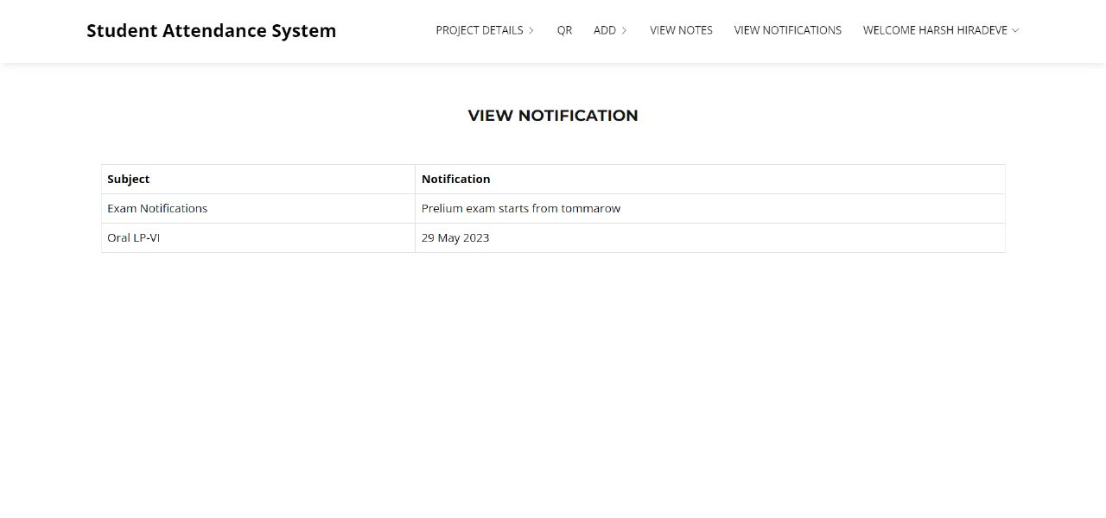

**Fig 18:- View Notes**

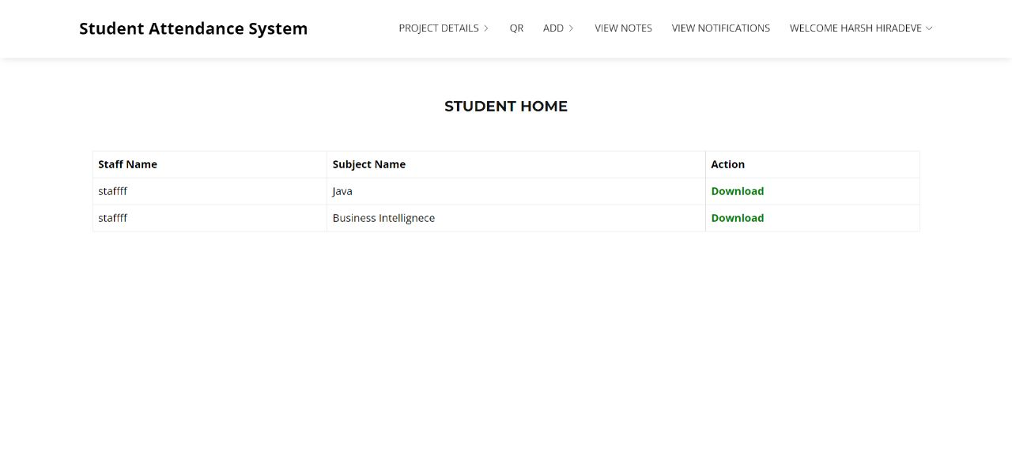

**Fig 19:- Download Notes**

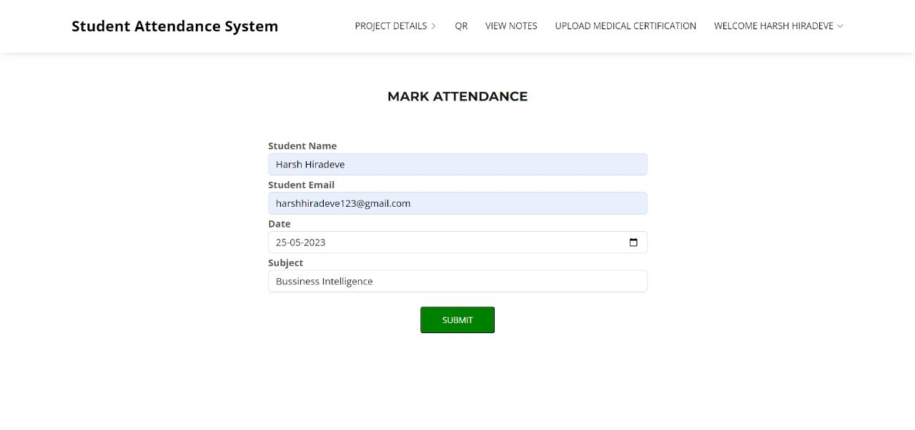

**Fig 20:- Mark Attendance**

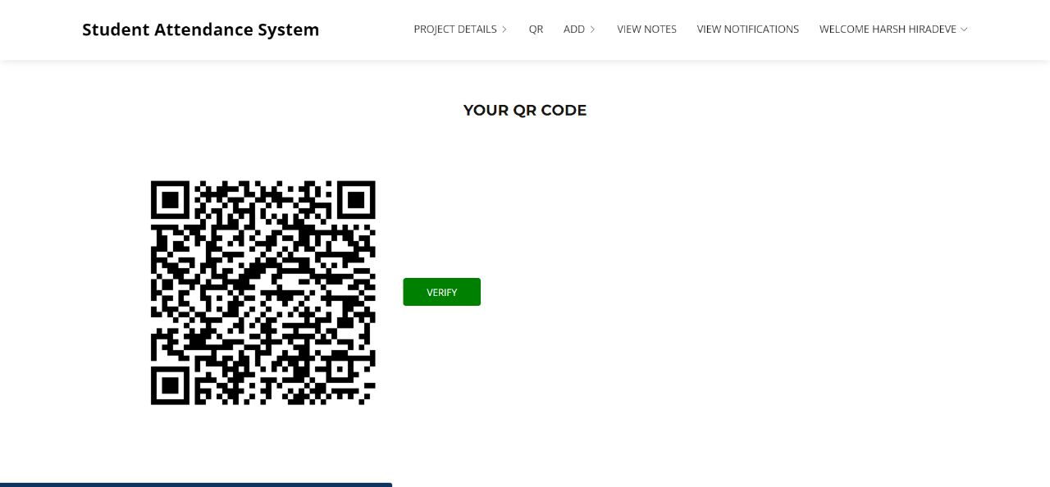

**Fig 21:- Personal QR-Code**

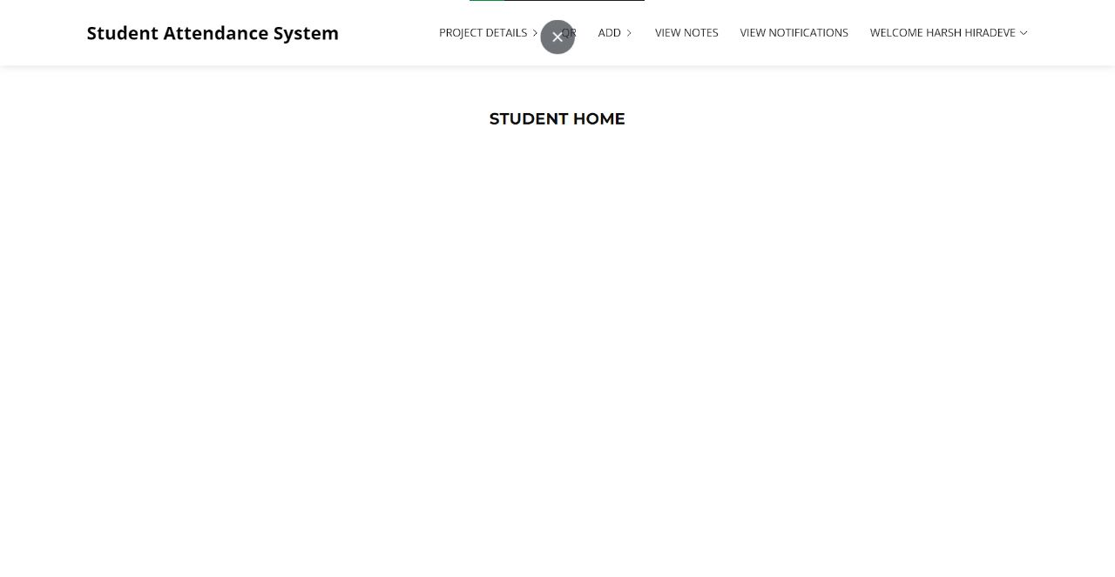

**Fig 22:- Student Home Page**

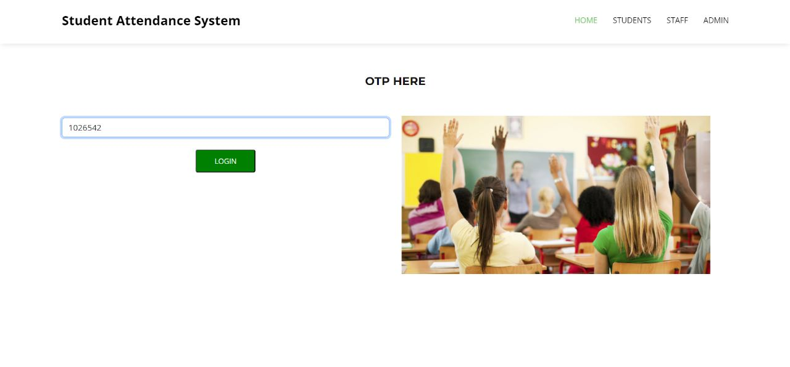

**Fig 23:- OTP**

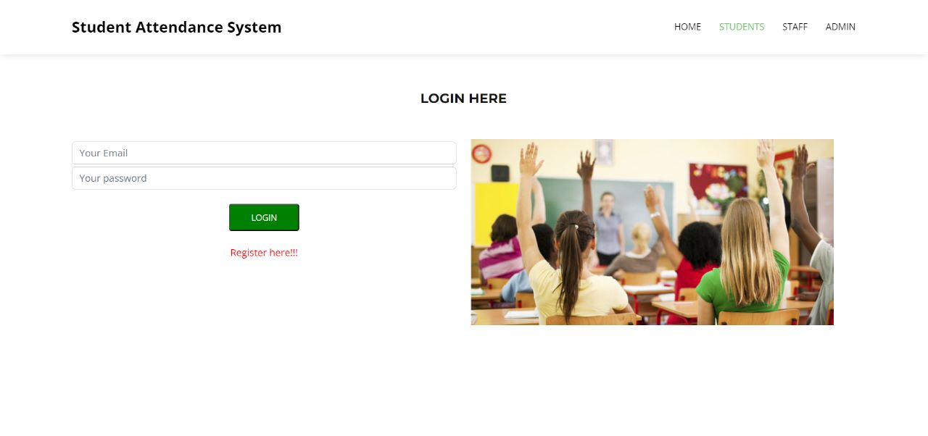

**Fig 24:- Student Login Page**

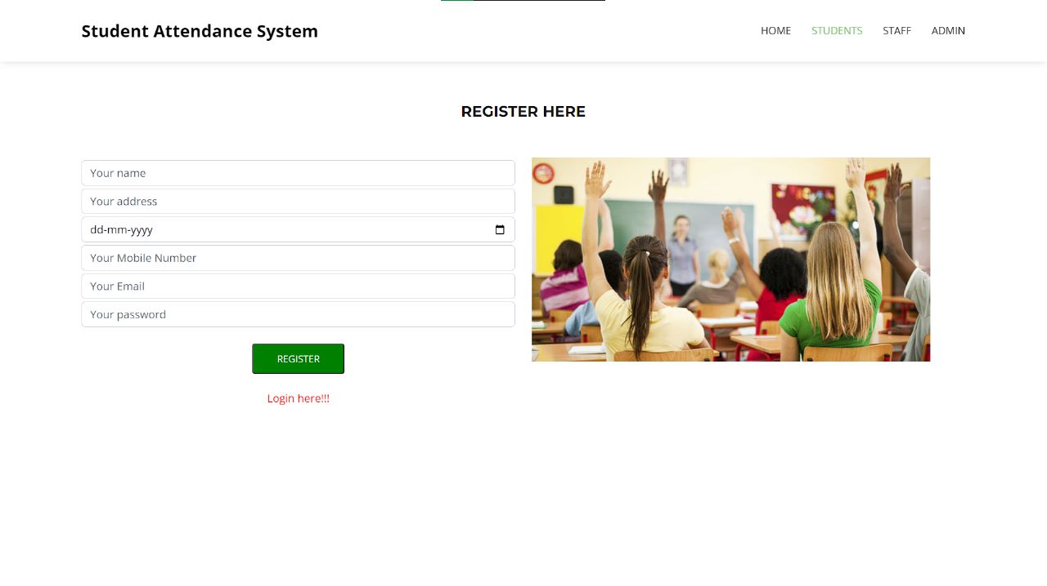

**Fig 25:- Student Register Page**

**CHAPTER 9**

**Merits and Demerits**

**9.1 Merits**

**QR-based attendance systems offer several advantages:**

**1. Convenience:** QR codes can be easily generated and scanned using smartphones or other devices. Participants can quickly scan their codes, eliminating the need for manual registration or sign-in processes.

**2. Cost-effective:** QR-based attendance systems are generally cost-effective compared to traditional methods that involve physical attendance registers or biometric devices. They require minimal infrastructure and can utilize existing devices like smartphones or tablets.

**3. Real-time data**: QR codes allow for immediate data capture, providing real-time attendance tracking. This enables administrators to have up-to-date information on attendance status, allowing for better decision-making and timely interventions if needed.

**4. Accuracy:** QR codes offer a reliable and accurate means of tracking attendance. Scanning QR codes eliminates the possibility of manual errors that can occur with traditional methods, such as paper-based sign-in sheets.

**5.Customization and integration:** QR codes can be customized to include additional information, such as participant names or identification numbers. They can also be integrated with other systems, such as student management or human resources software, for streamlined data management.

**6. Data analysis and reporting:** QR-based attendance systems generate digital data that can be analyzed and used for reporting purposes. Attendance patterns, trends, and statistics can be easily extracted from the collected data, aiding in decision-making and assessing participant engagement.

**7. Contactless and hygienic:** QR codes eliminate the need for physical contact or the sharing of devices, making them a hygienic option, especially in situations where personal hygiene is crucial, such as during pandemics or contagious outbreaks.

Overall, QR-based attendance systems offer a user-friendly, cost-effective, and efficient way to track attendance while providing accurate and real-time data for analysis and decision-making purposes.

**9.2 Demerits**

**QR-based attendance systems, while convenient and widely used, have a few limitations:**

**1. Dependency on smartphones or devices:** QR-based attendance systems require participants to have smartphones or devices with QR code scanning capabilities. This can be a limitation if participants don't have access to smartphones or if the devices are not functioning properly.

**2. Internet connectivity:** QR codes often contain URLs that need to be accessed for attendance tracking. This requires a stable internet connection. In cases where the internet is unreliable or unavailable, the attendance system may not function properly.

**3. Possibility of QR code manipulation:** QR codes can be easily replicated or manipulated. In some cases, participants may share or forge QR codes, allowing someone else to mark their attendance even if they are not physically present.

**4. Lack of biometric verification**: QR codes only provide a means of identification, but they do not verify the identity of the person scanning the code. This can lead to instances of proxy attendance, where someone else scans the QR code on behalf of the actual participant.

**5. Privacy concerns:** QR-based attendance systems collect personal data, such as the timestamp and location of attendance. There may be privacy concerns if the data is not handled and stored securely, or if it is used for purposes beyond attendance tracking without proper consent.

**6. Potential for technical issues:** QR codes can become damaged, unreadable, or distorted, which may result in difficulties scanning them. Technical glitches or malfunctions can also occur with QR code scanning apps, leading to inaccuracies or failures in attendance tracking.

**7. Limited scalability:** QR-based attendance systems may face challenges when handling a large number of participants simultaneously. Scanning QR codes individually for each participant can be time-consuming and may cause congestion in high-traffic areas.

**8. Inability to capture real-time attendance**: QR codes are typically scanned at a specific moment, which may not accurately reflect the actual duration of someone's presence. This can be problematic for scenarios where continuous or real-time attendance tracking is required.

It's important to consider these limitations when implementing a QR-based attendance system and to address them accordingly to ensure accurate and reliable attendance tracking.

**9.3 Future Scope**

* Biometrics (iris) integration in the system using Specialized Camera.
* Mail sending to the respective students and their parents to keep track of their attendance.
* Multi-Platform Development which includes application itegration for both iOS and Android Devices.
* IP integration for controlling the range of marking the attendance in particular zone.

**CHAPTER 10**

**CONCLUSIONS**

**10.1 Conclusions**

Nowadays, being current with technology is essential, especially in the realm of education. The latest technologies are being used by educational institutions to improve the educational process. We believe that this system is basically essential for the University given the trend toward digitization. In this essay, we have discussed a potential system for recording student attendance that uses QR codes and internet-connected gadgets. This study demonstrates how the multifaceted and widely utilised QR code capability of smart devices may be used to efficiently record attendance in place of the previous, conventional approach of calling name lists in class.

**CHAPTER 11**

**REFERENCES**

**11.1 REFERENCES**

1.Muhammad Ayat Hidayat, HolongMarisiSimalango,”Students attendance system and Notification of college subject Schedule based on classroom using Ibeacon”, 2018 3rd International Conference on Information Technology, In- formation Systems and Electrical Engineering(ICITISEE), Yogyakarta, Indonesia, 978-1-5386-7082-8/18/.

2.Dr.Nkolika O. Nwazor, Mumuni M. Olusolape,”Cloud based Attendance Man- agementandInformation System”,(IJERT)ISSN: 2278-0181, Vol. 10 Issue 09, September-2021.

3.FawazAlassery, member IEEE,”A Smart Classroom of Wireless Sensor Net- works for Students Time Attendance System”,2019 IEEE Integrated STEM Education Conference (ISEC).

4.NandgopalDevnath,NitinPasi,”QR Code Based Smart Attendance System”, International Journal of Smart Business and TechnologyVol. 5, No. 1, (2017), pp.1-10.

5.VasutanTunbunheng,”Automatic Attendance Systemfor Late Student using Speech Recognitioncorresponding with Google Forms and Sheets”,2017 10th International Conference on Ubi-media Computing and Workshops (Ubi- Media).

6.Dongmei Feng, Peng Wang, Lei Zu, ”Design of Attendance Checking Manage-

ment System for College ClassroomStudents Based on Fingerprint Recognition”,978- 1-7281-5855-6/20/31.00c 2020 IEEE.

7.Jaehoon (Paul) Jeong¬, Minho Kim, Yeonghyeon Lee, and Patrick Lingga, ”IAAS: IoT-Based Automatic Attendance Systemwith Photo Face Recogni- tion in Smart Campus”,978-1-7281-6758-9/20/31.00 ©2020 IEEE.

8.Jack FebrianRusdi,Frans Richard Kodong,RichardusEkoIndrajit,Herry So- fyan,Abdurrohman,RobertMarco,”Student Attendance using Face Recog- nitionTechnology”,IEEE,2021.

9.Asri Nuhi,AgonMemeti,FlorindaImeri,BetimCico,”Smart Attendance Sys- tem using QR Code”,978-1-7281-6949-1/20/31.00 2020 IEEE.

10.Dr.S.Matilda, K.Shahin,” Student Attendance Monitoring System Using Im- age Processing”, international conference 2019,@IEEE.

**Survey paper**

**and certificates**

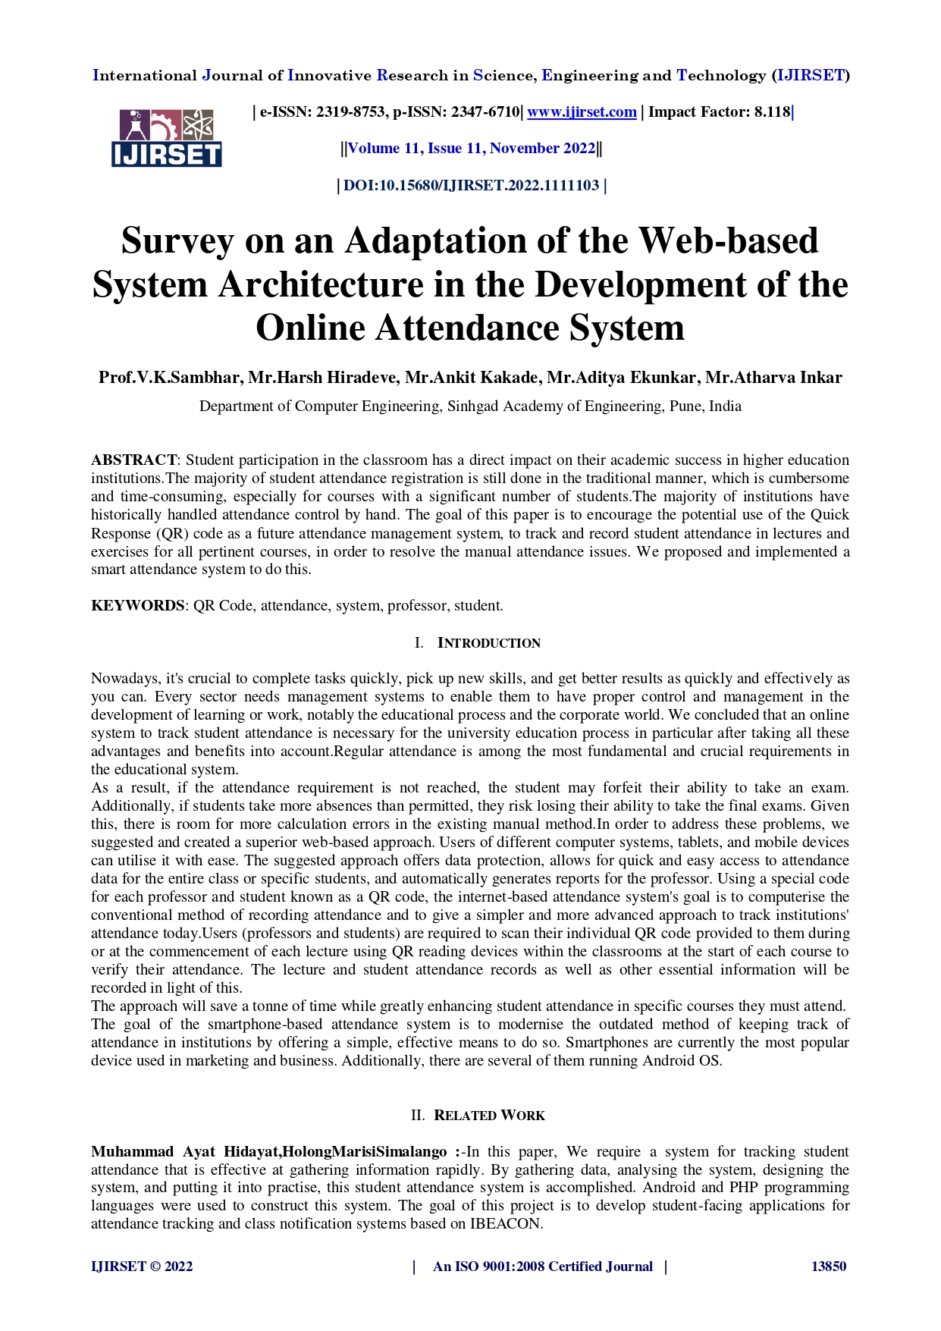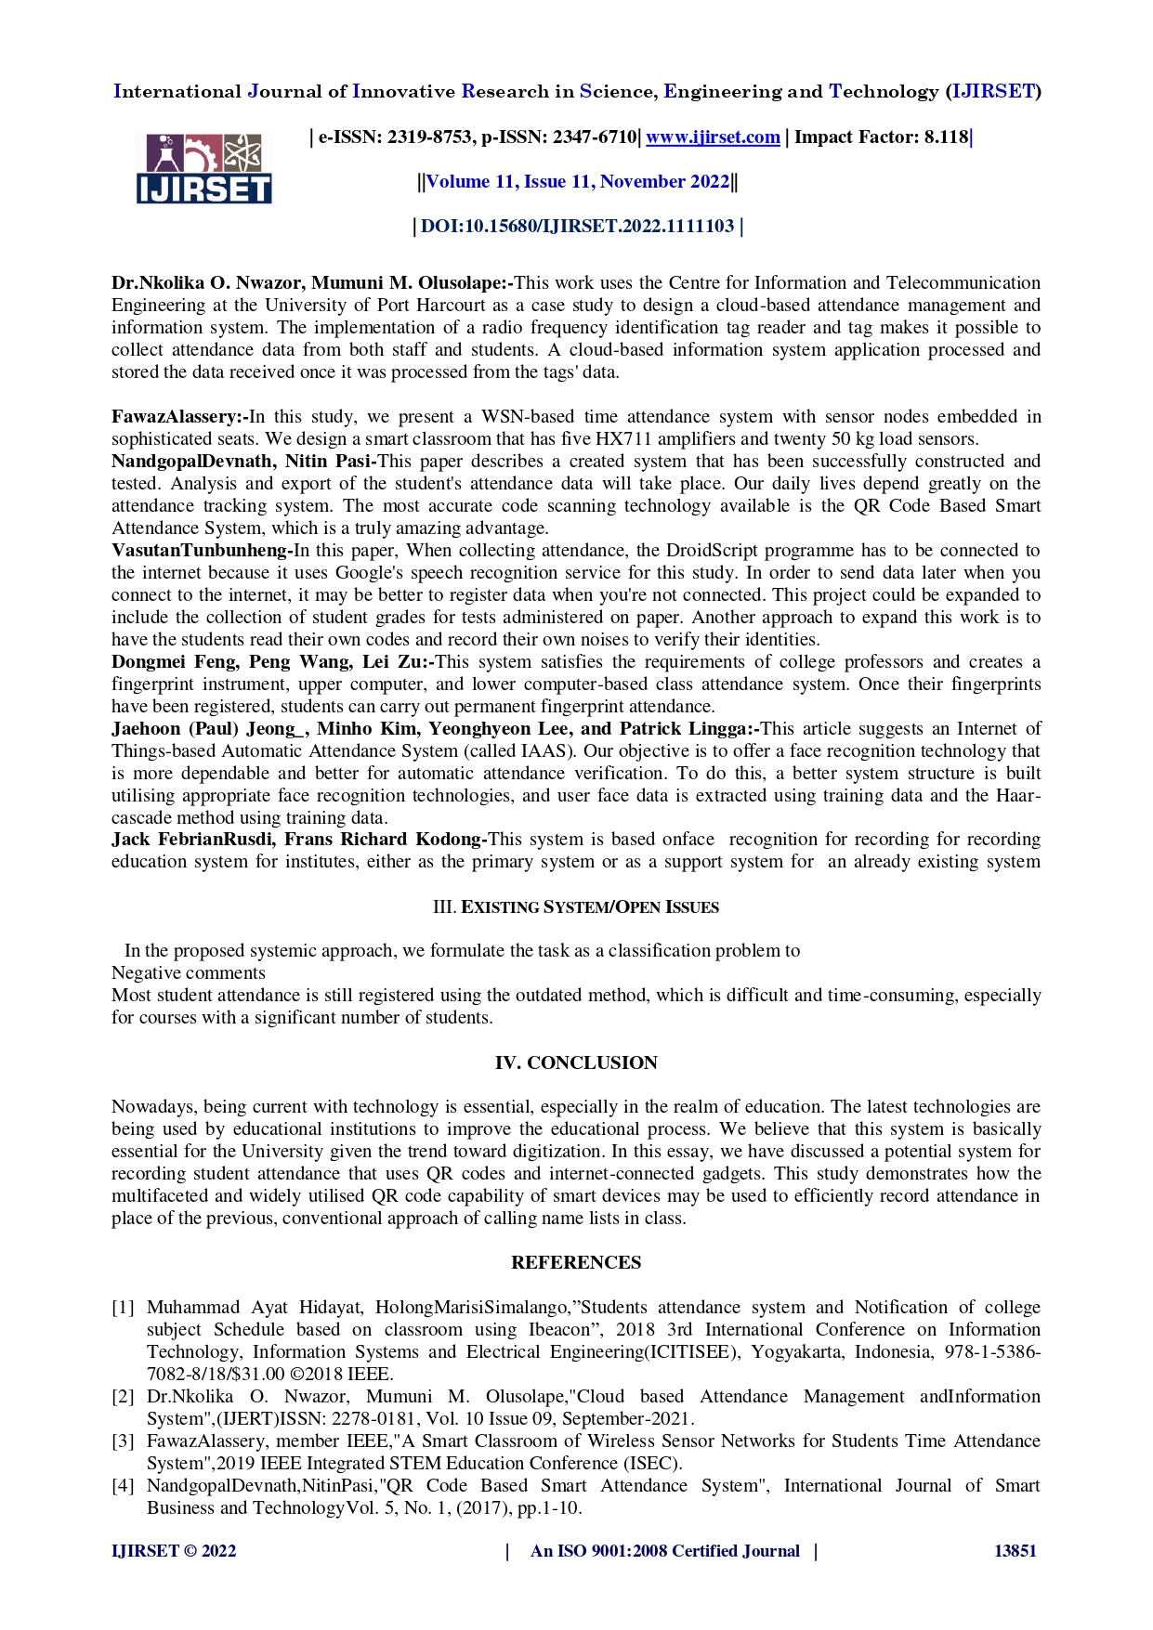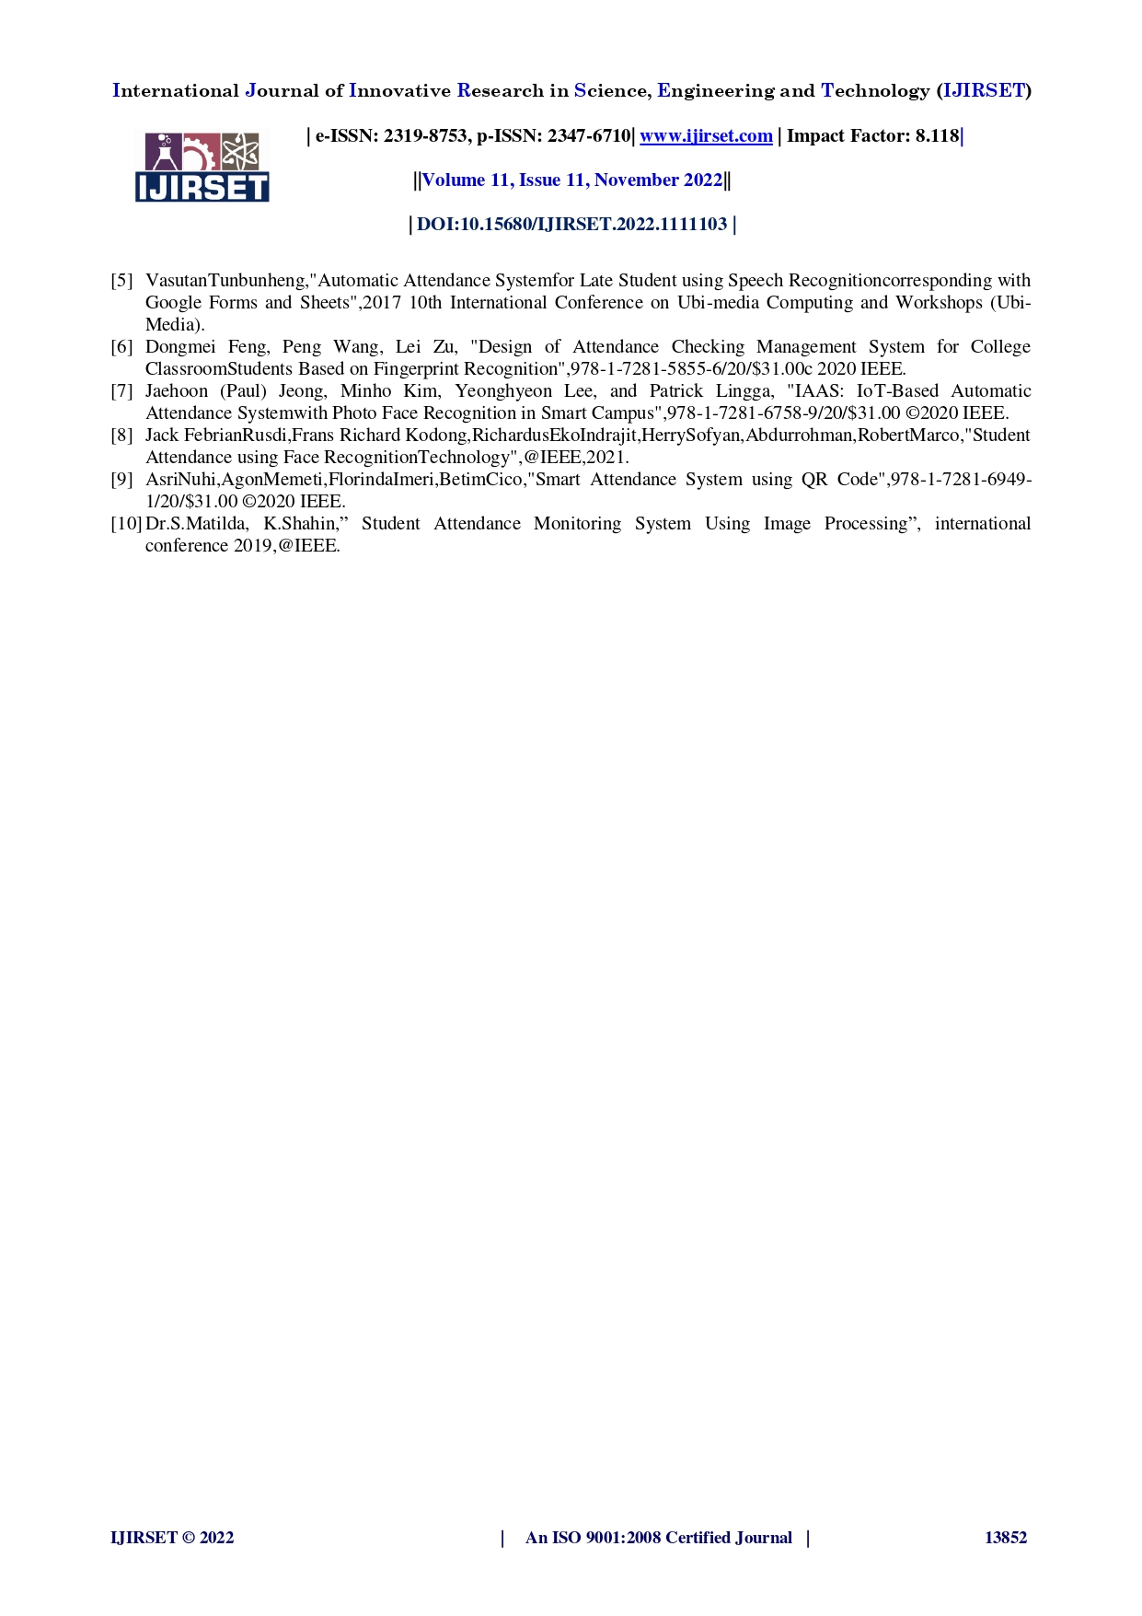

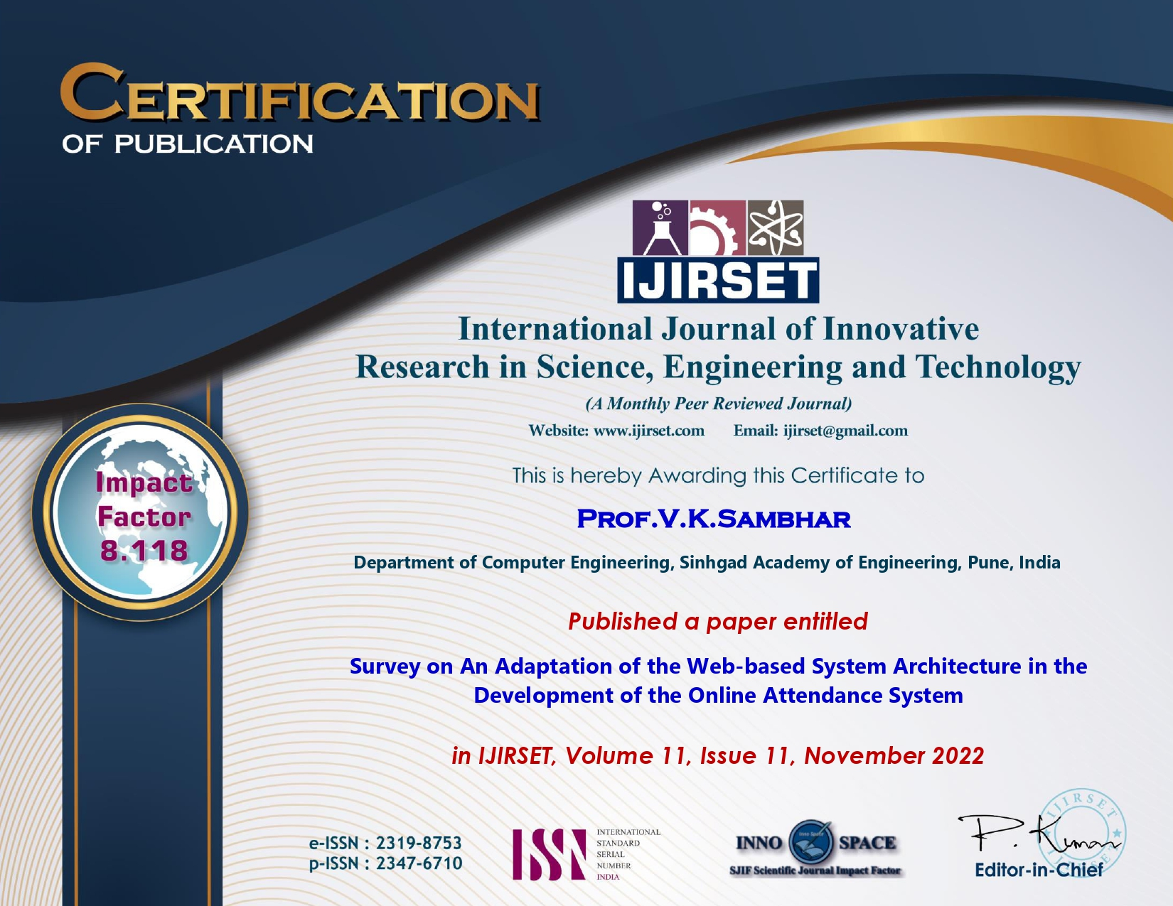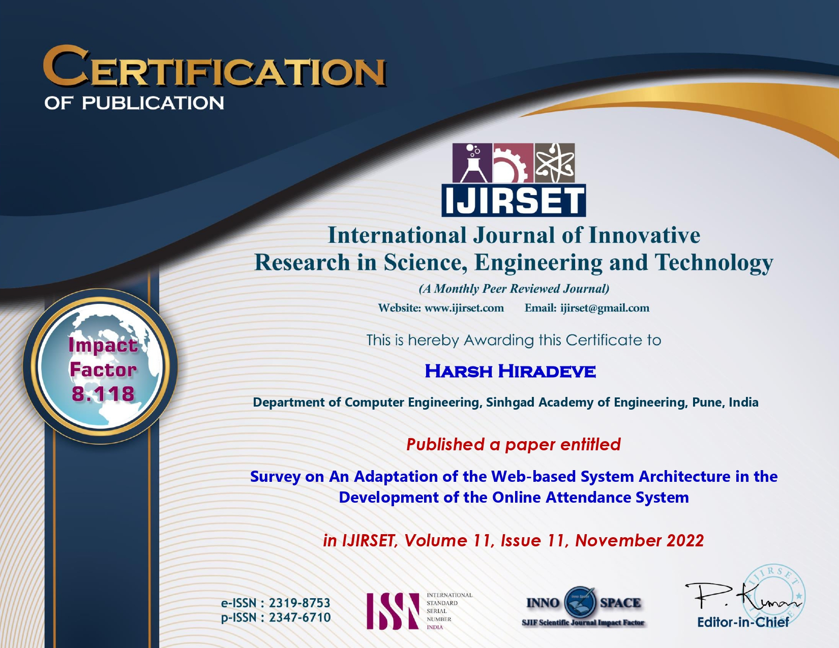

**iMPLEMENTATION PAPER**

**AND CERTIFICATES**

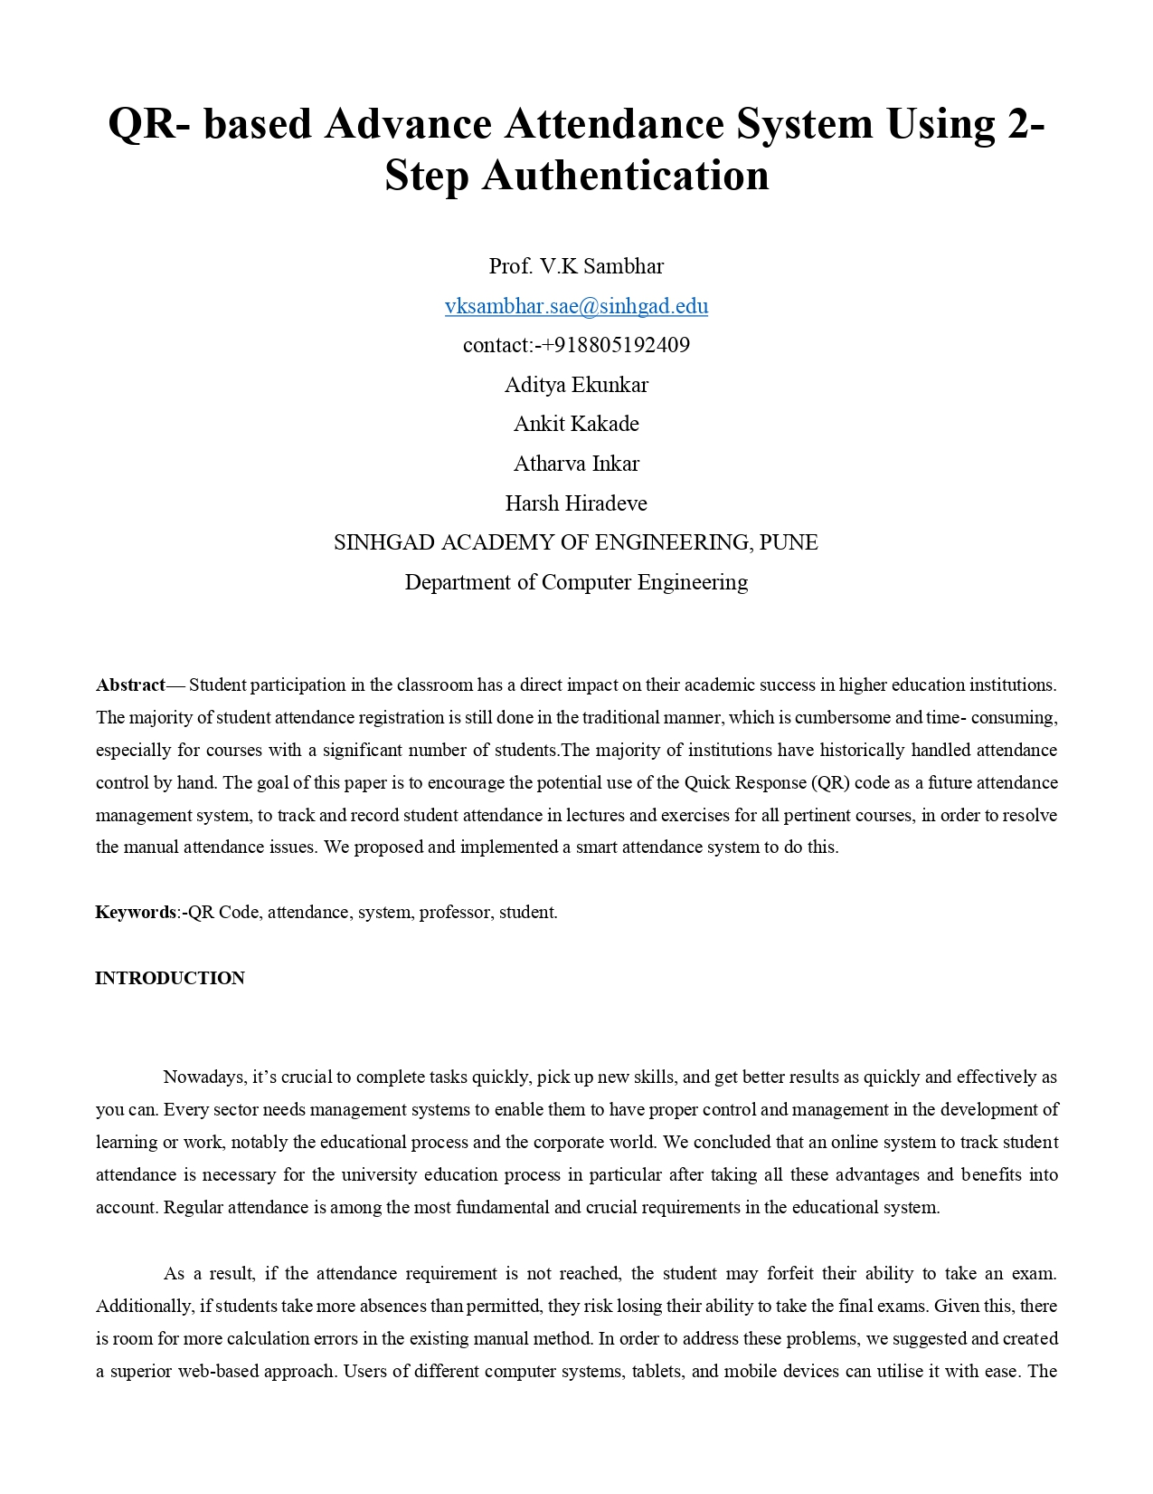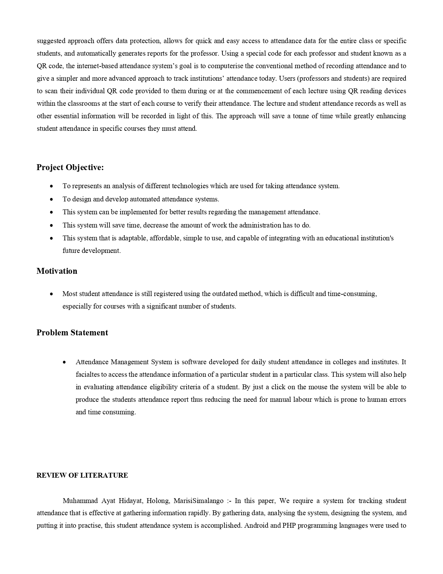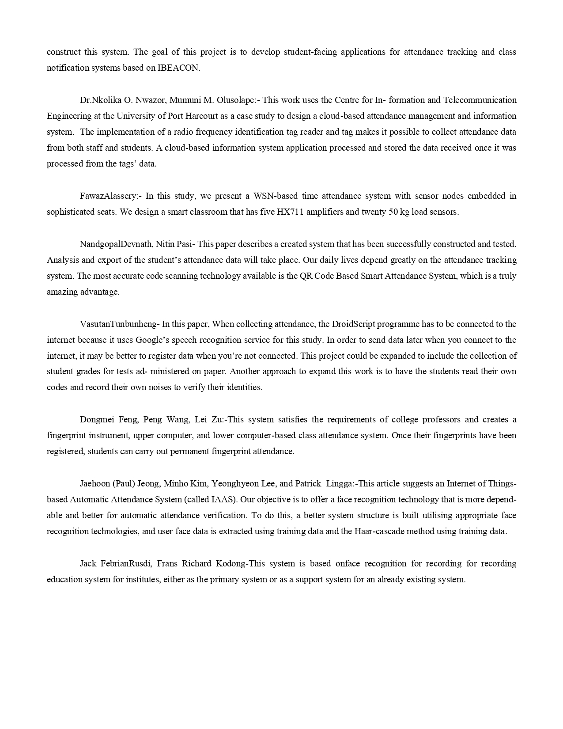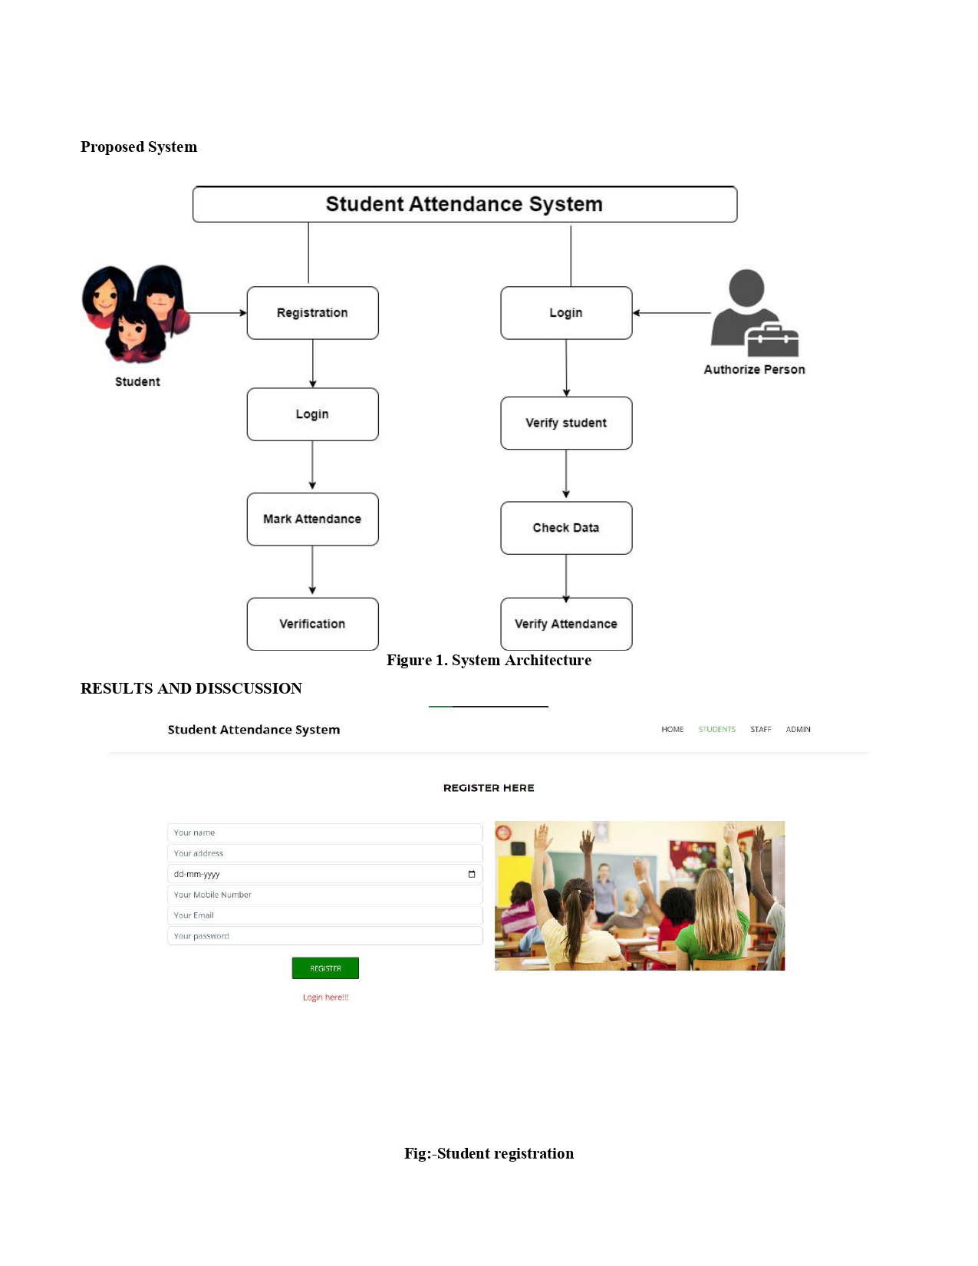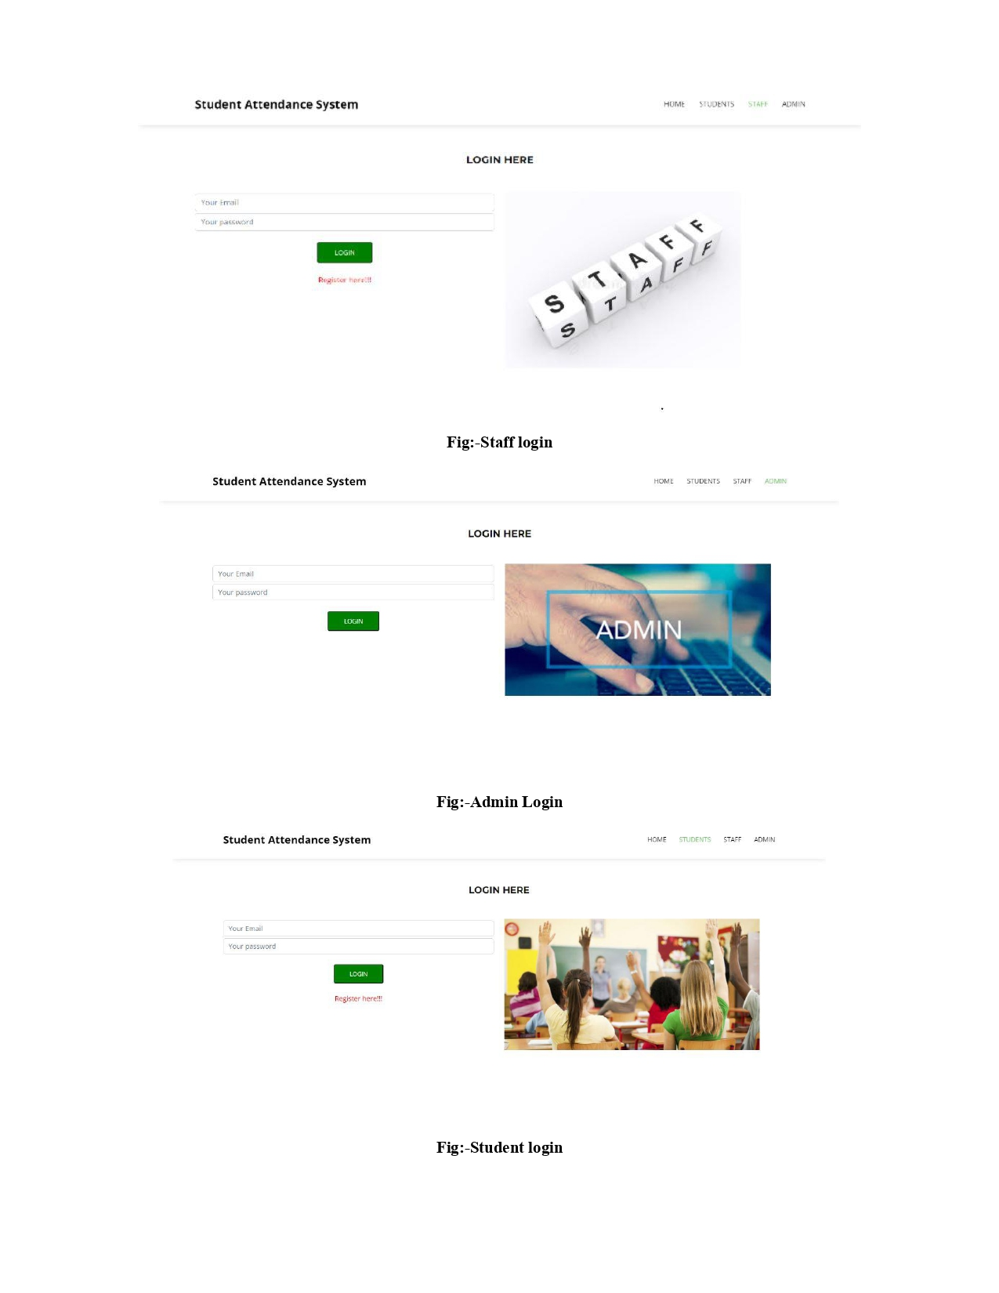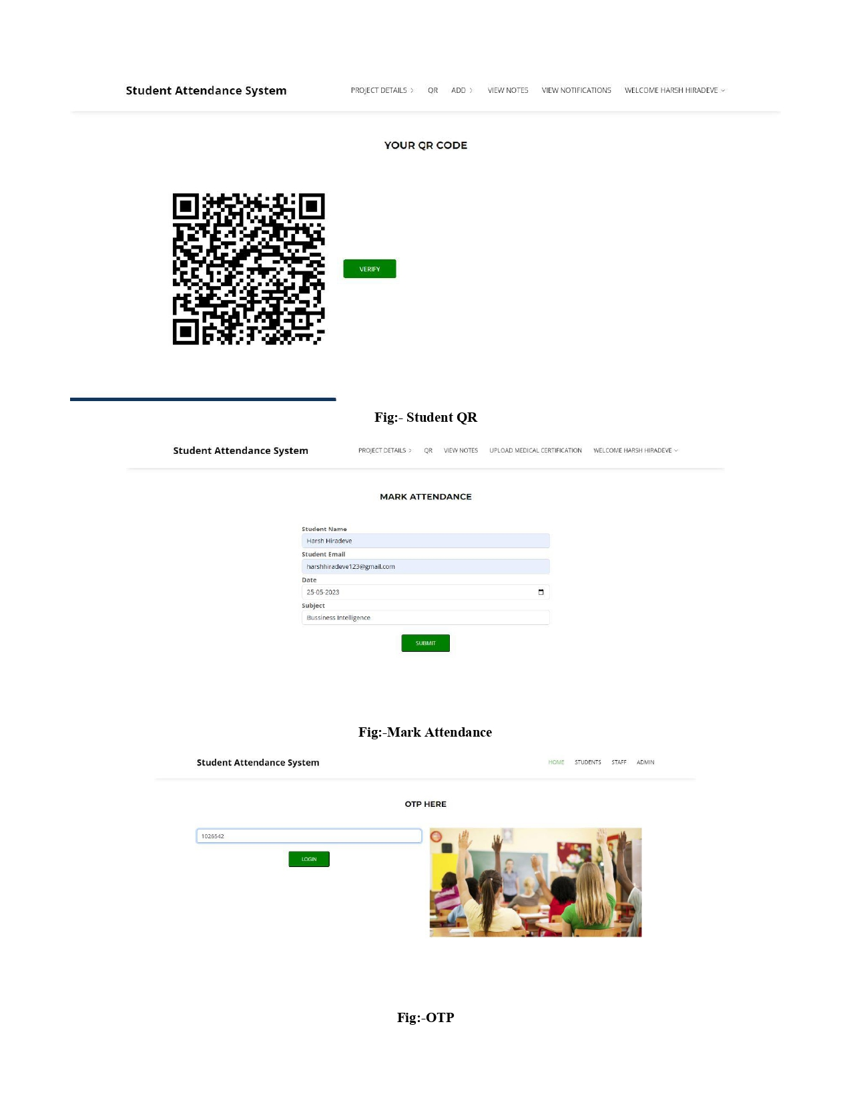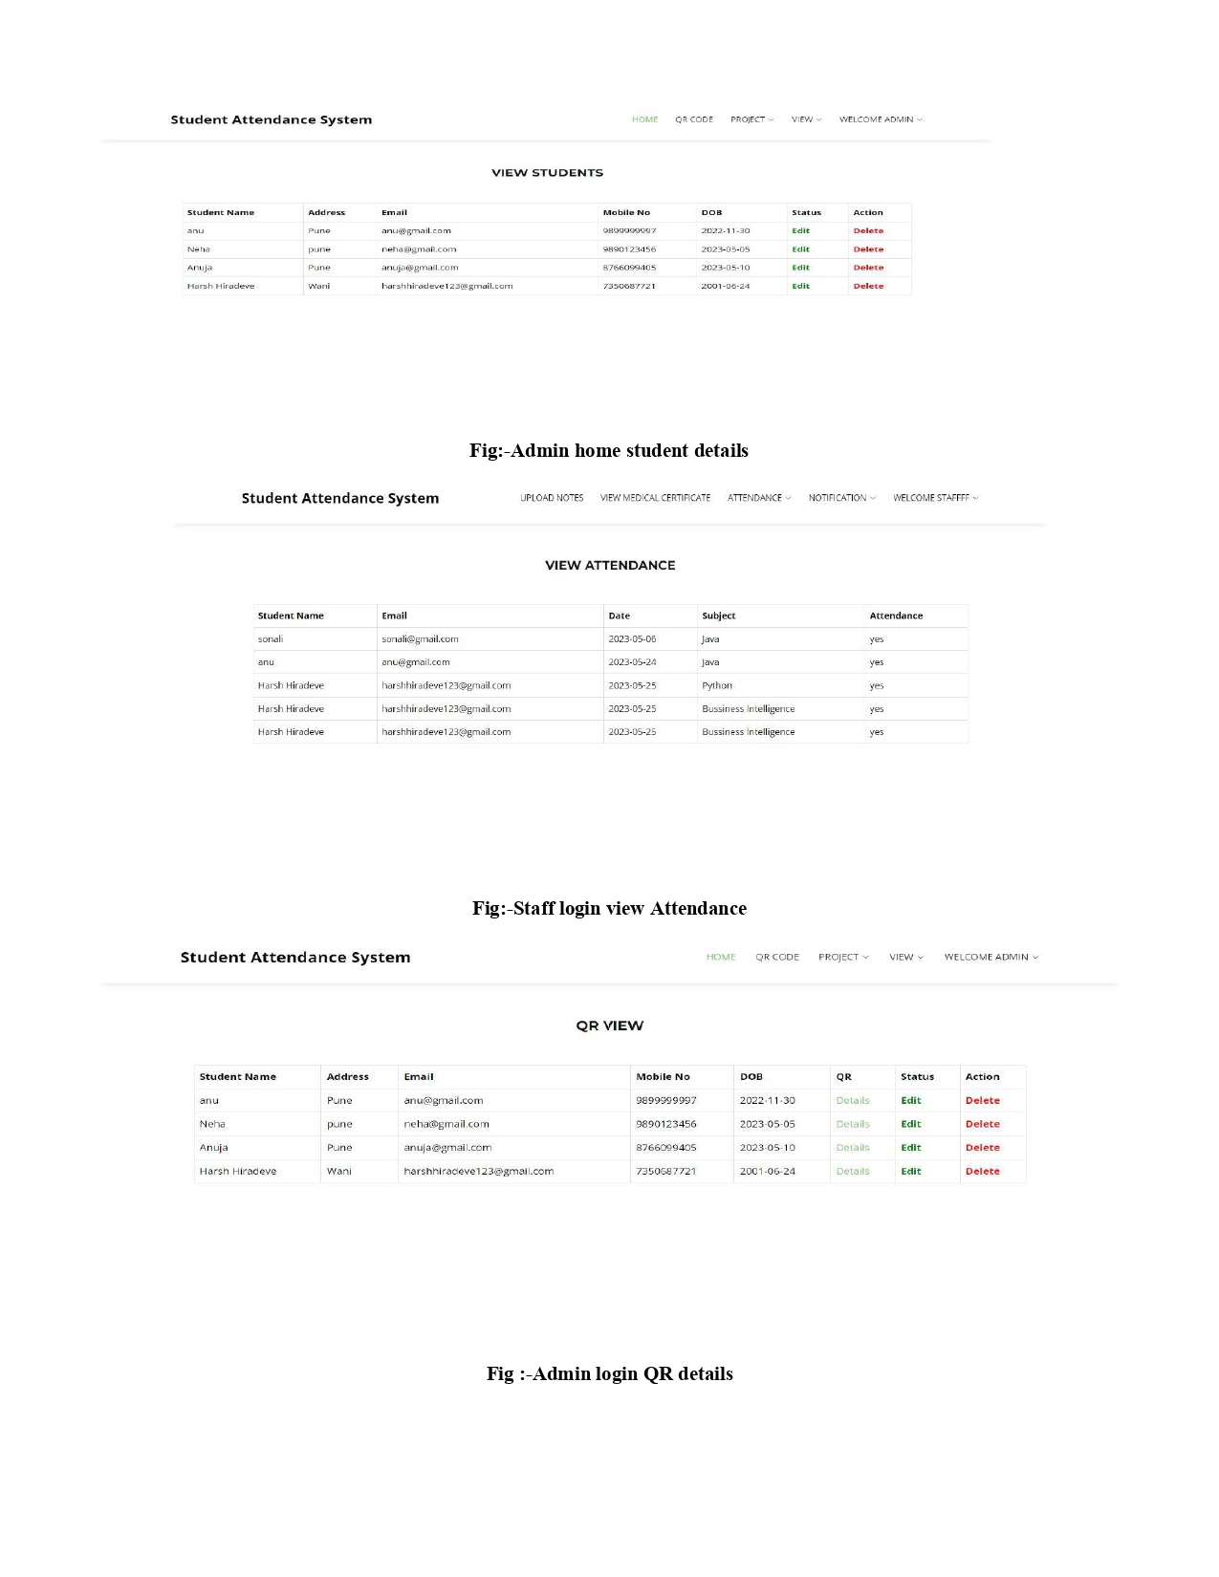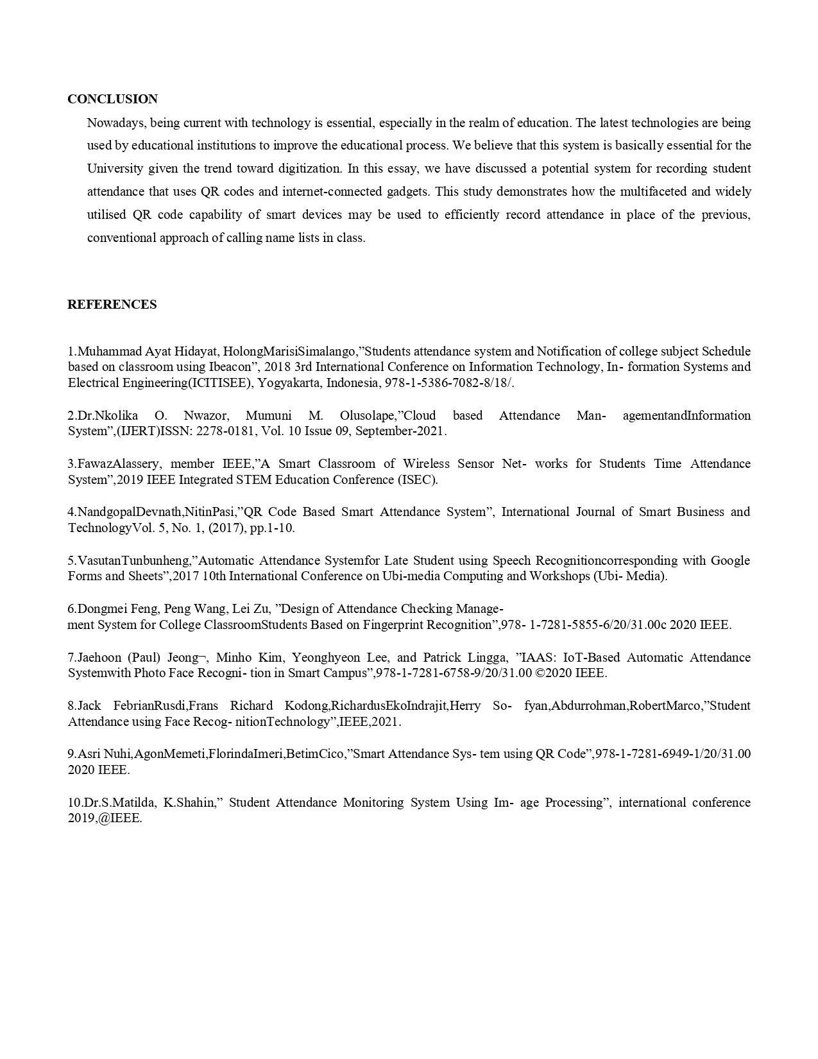



**Plagiarism Report**

